# Unit 3: Christian Art and Where it Belongs

## Overview

In this unit, we will continue to ask, ‘what is Christian art’ and ‘where does it belong’? We will learn from theologians about the role of artists in the development of liturgy, ask where Chrisian art belongs and what the museum or gallery context for fine art has to do with Christian life, as well as consider how and whether Christians can be called into a lifelong (career) vocation as artists. There is an ever-growing appreciation for art in many churches and increasing theological support for artists using their skills in liturgical contexts, but there is less consensus about whether the contemporary art world (its institutions, funding models, secular context) is a healthy context in which for Christian artists to be involved. We will hear several perspectives on the matter, and then finish by considering Christian artistic vocation. We will also begin to consider some of the ways in which the aesthetic part of life is not limited to production of fine art, but is an integral part of Christian living and life more generally.

### Topics

This unit is divided into the following topics:

1. Christian Vocations in The Arts
2. Liturgical Arts
3. Museums and Institutions

### Unit Learning Outcomes

When you have completed this unit, you will be able to:

* Describe and defend the importance of Christian artists being involved in liturgical arts and the importance of churches supporting artists in their faith communities.
* Appraise differing points of view on whether the art-institutional/museum context for the display and support of fine art is beneficial to Christian artists and society at large.
* Create an aesthetic audit of your environment and behaviors: in places of worship, at work, and at home.

### Learning Activities

Here is a list of learning activities that will support you in completing this unit. You may find it useful for planning your work.

**<Begin learning-activity>**

* **Art as Christian Calling:** Read two authors discuss whether God calls people to a life of artistic vocation.
* **Support an Artist:** Brainstorm how to support artists in your faith community.
* **Artistry as Personal Transformation:** Listen to a woodworker talk about what changes the artist undergoes in the act of creating.
* **Pentecost and the Holy Spirit -** **Visual Art in Churches:** Look at four contemporary art installations in churches that focus on the Holy Spirt or Pentecost.
* **Be a Stranger:** Take a few minutes to consider your physical surroundings and how they shape your experiences in them.
* **Art and Christian Community:** In this lecture, an art historian discusses what a cathedral in the Italian town of Orvieto meant to the locals, and what role artisans played in shaping its liturgical function.
* **What do Liturgy and Liturgical Art offer?** Hear from people across several church traditions talking about the different functions liturgy and art might play in the life of the faithful.
* **A History Lesson on Museums, Craftspeople, and Patrons:** Read about the historical origins of our modern context for museums and artistic patronage.
* **The Aesthetic Beyond the Museum:** Consider why it is important to think about fine art in contexts other than the museum, and also consider what museums offer society and people of faith.

**<Begin note>**

Working through these activities will help you to meet the learning outcomes and successfully complete your assessments.

**<End note>**

**<End learning-activity>**

### Assessment

See the Assessment section in Moodle for assignment details.

### Required Texts and Materials

Here are the resources you will need to complete this unit.

* Seerveld, C. (2000). *Bearing Fresh Olive Leaves: Alternative Steps in Understanding Art*. Toronto Tuppence Press.
* Wolterstorff, N. (1996). *Art in Action: Toward a Christian Aesthetic* (1st edition). Eerdmans.

Other online resources will be provided in the unit. Refer to the References section at the end of the unit for the full list.

## Christian Vocations in the Arts

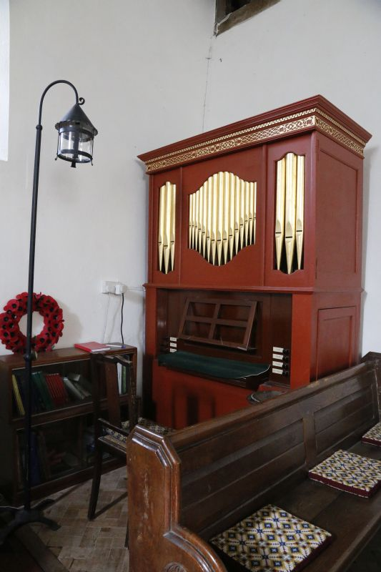

*Making art for church or being a church musician are not the only ways to be a Christian artist. Liturgical artist and church musician are, however, important callings. Seerveld argues that artists working in and beyond the church both need to be prioritizing imagination and pursuing increased understanding of God, no matter the context or subject of their work.*

*From* [*Wikimedia*](https://commons.wikimedia.org/wiki/File:Organ_in_the_Church_-_geograph.org.uk_-_3990255.jpg)*, Bill Nicholls, 2014), Creative Commons*

It goes without saying that it is not possible to have art function liturgically, in the narrow sense of a church’s liturgy or architecture, or broadly as an instrument of delight or encouragement, without imaginatively engaged Christians. There is some confusion, however, about whether all Christians are meant to engage in this work, or some people are especial ‘geniuses’ in this regard. To Calvin Seerveld’s mind, the idea that there are some people who are gifted a kind of genius is an unchristian idea from the Renaissance. Giorgi Vasari wrote a book entitled The Lives of the Artists in which he praised a certain manner of working and elevated certain artists (Michelangelo especially) as prime examples of artistic genius. The mark of a talented artist was the ease with which they worked, the understated nature of their works. In other words, an artist who struggled to gain skill was simply not a genius. “The greatest gifts often rain down upon human bodies through celestial influences as a natural process, and sometimes in a supernatural fashion a single body is lavishly supplied with such beauty, grace, and an ability that wherever the individual turns, each of his actions is so divine that he leave behind all other men and clearly makes himself known as a genius.” (Vasari, 2008, 284) So great an emphasis on genius is not only unbiblical, Seerveld argues, but it also misses out on the fact that many are not given the opportunity for skill development. He urges christian communities to support rather than stand in the way of those who have calling.

“No one thing has ruined art so much in Western civilization as the cumulative nonsense about the artist as supra-rational genius, the pious talk about creativity, and the Romanticist creed that undisciplined bohemian life afforms the milieu most conducive for having artistic ‘inspiration’ strike. Such adulatory isolation may prime artist egos, but it inevitably undermines the ministry of Christian art.” (Seerveld, 2005, 196).

Instead he urges Christian artists to grow in five regards, (Seerveld 2005, 196):

1. Become filled with the wisdom of the Holy Spirit.
2. Conceive art as work and undergo its training like a trade.
3. Distill a faithful christian art historical tradition in your own blood and pioneer its contribution in our day.
4. Integrate yourself as a band of christian artists.
5. Persevere in unfolding art historically, with a generations-long patience and hope.

The biblical charter for art begins in the old testament, he says, not just by blessing craftspeople to create for the temple, but by containing artistic writing that expands our understanding of God and human life. Art does not simply represent reality as beautiful, tragic, etc, but finds new ways to relate to those experiences, just as the Psalms of Lament do. Furthermore, art is not just read as parables with a spiritual lesson, as Timothy Gorringe suggests (Gorringe, ____), but even more generally is a style of storytelling that layers multiple meanings in precisely the way that a parable does. “Peculiar to art is a parable character, a metaphoric intensity, an elusive play in its artifactual presentation of meanings apprehended. Art calls to our attention in capital, cursive letter, as it were, what usually flits by as fine print.” (Seerveld, 2005, 27) *Art acts like a parable, not just as a parable story with a fine lesson.*  
The trouble s, our society at large does not seem set up to support obedience to these artistic callings. Seerveld asks -- through his writings on artistic calling -- how do we feel about the fact that our lack of support, of art in church or art in our homes, limits other people in our community from responding to God’s calling? Do you know someone to whom this description applies? Someone in your life whose work life is permanently directed toward other ends because they could not support themselves for their families if they respected the talents God gave and wanted to develop them through education or apprenticeship? Perhaps this applies to you? If yes, in either case, what are the effects? Are you or they deprived in a spiritual sense, in an emotional sense?

### Gallery



### Activity: Art as Christian Calling

**<Begin learning-activity>**

**Estimated Time: 90 mins**

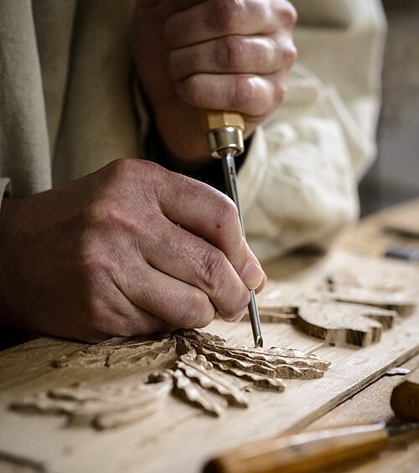

*Is artistic work a calling from God? What can we do to help make art and craftswork possible as a vocation?*

From [*Wikimedia*](https://upload.wikimedia.org/wikipedia/commons/thumb/2/2a/Patrick_Damiaens_Houtornamentist_-Ornamentist.jpg/500px-Patrick_Damiaens_Houtornamentist_-Ornamentist.jpg) (Patrick Damiens, 2014). Creative Commons

**Mandatory Readings:** Read two perspectives about vocational calling for Christian artists. Calvin Seerveld considers what is redemptive about art in order to consider the value of Christian artists, and shows examples of redemptive artwork from several different eras. Completing these readings will help you be successful in projects later in the course, especially the final ‘Cultural Critic’ project, by helping you consider the diverse ways artists contribute to spiritual and cultural renewal.

* **Read:** Seerveld, “Redemptive Artistry in Contemporary Culture,” in *Bearing Fresh Olive Leaves: Alternative Steps in Understanding Art* (2000), pp. 87–115.
* **Read:** Wolterstorff, “The Artist as Responsible Servant,” in *Art in Action: Toward a Christian Aesthetic* (1996), pp. 67–90.

**Questions to Consider:**

* How are their accounts similar or different?
* Where do each writer suggest artists go to work? Who do they suggest are the audiences for Christian artist’s work? Is it other Christians, the general public, both?, etc.
* Is there a specific era of art that is more redemptive?

**<End learning-activity>**

### Activity: Support an Artist

**<Begin learning-activity>**

**Estimated Time: 10-20 mins**

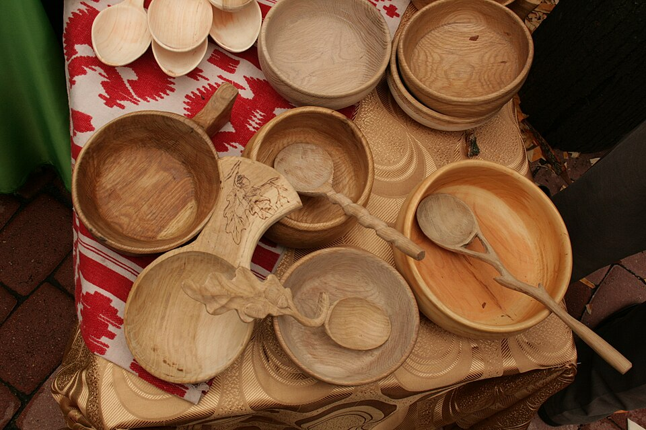

*Skillful artists and craftspeople are probably already in your faith community!*

From [*Wikimedia*](https://upload.wikimedia.org/wikipedia/commons/thumb/f/fa/%D0%9B%D0%BE%D0%B6%D0%BA%D0%B0%D1%80%D1%8C_%D0%A0%D0%B0%D0%BA%D0%B8%D1%82%D1%8F%D0%BD%D1%81%D0%BA%D0%B8%D0%B9_12.JPG/960px-%D0%9B%D0%BE%D0%B6%D0%BA%D0%B0%D1%80%D1%8C_%D0%A0%D0%B0%D0%BA%D0%B8%D1%82%D1%8F%D0%BD%D1%81%D0%BA%D0%B8%D0%B9_12.JPG)(Lobachev Vladimir, 2013). Creative Commons.

Do you already know a fine artist, craftsperson, or artisan within your immediate (especially local) faith communities? Do you benefit from the work of a liturgical artist or musician in your place of worship? If not, try to spend a few minutes looking for someone, or an artist’s collective, gallery, or project near you. Often, people who feel a vocation to work in the arts will have irregular or tentative employment, or will not have the time or resources to follow their vocation because they are caregivers or working full-time elsewhere to serve their families. Often, musicians and liturgists in our churches do the work for free and almost certainly do not receive enough encouragement or thanks. Once you have found a local artist/potter/woodworker/musician, show some support:

**Ways to show support:**

* Write a note of encouragement: “I really appreciate your work/it moves me because.../you make beautiful pieces and I can’t support your work at the moment but I wanted you to know I see its value and I hope you feel empowered in your work/your choice of music and scripture was so thoughtful and created a great atmosphere for worship this week.”
* Encourage others to do the same. Seriously. Write to a few people and ask them to share some encouragement or support for your liturgical team/an artist in your congregation.
* Buy their work if able, consider it for upcoming birthday/holiday presents (wouldn’t the money ‘needed’ for Christmas presents be less ‘painfully’ spent if it benefited someone in your community?), or add it to a wishlist for others looking for thoughtful gift ideas.
* Follow their work on social media, share their work on your own socials, or send links to their work to friends or family. Even if you cannot afford to support an artist at this time, sharing might help them get a sale through one of your contacts.
* Bonus: can you be an advocate for these same artists in your faith communities over the long term?, perhaps asking your church to commission work for the sanctuary or setting up a craft fair to support artists and makers in your church and neighborhood? Can you make an effort to go to an existing fair that you have not gone to before? Even if you cannot buy, going and giving encouragement is still a form of support!

**<End learning-activity>**

### Activity: Artistry as Personal Transformation

**<Begin learning-activity>**

**Estimated Time: 25 mins**

Hear from author Peter Korn, who wrote the delightful book *Why We Make Things and Why it Matters,* on the changes brought about by handcrafting. Making is not just about the act of creating something, but involves a process of discovery about who one is and where true fulfillment in life comes from.

**Watch:** [*A Life's Work: The Philosophy of a Craftsman*](https://www.youtube.com/watch?v=zweMkuQc3pU) (2019)

<https://www.youtube.com/watch?v=zweMkuQc3pU>

**Questions to consider:**

* What was different about Korn’s parent’s generation and his own, in his telling? Is anything different today?
* What is gained through the act of making?
* Where do Korn and others interviewed suggest lasting satisfaction comes from? What does their answer highlight or add to our conversation, what does it leave out? (Hint: they seem to be talking about spiritual development and talking about it as emotional development. What aspects of their answer relate to emotions and maturity, intellectual development, and what part seems to be a spiritual kind of growth? Can spirituality, intellect, and emotions be neatly seperated in this way?)

**<End learning-activity>**

## Liturgical Arts

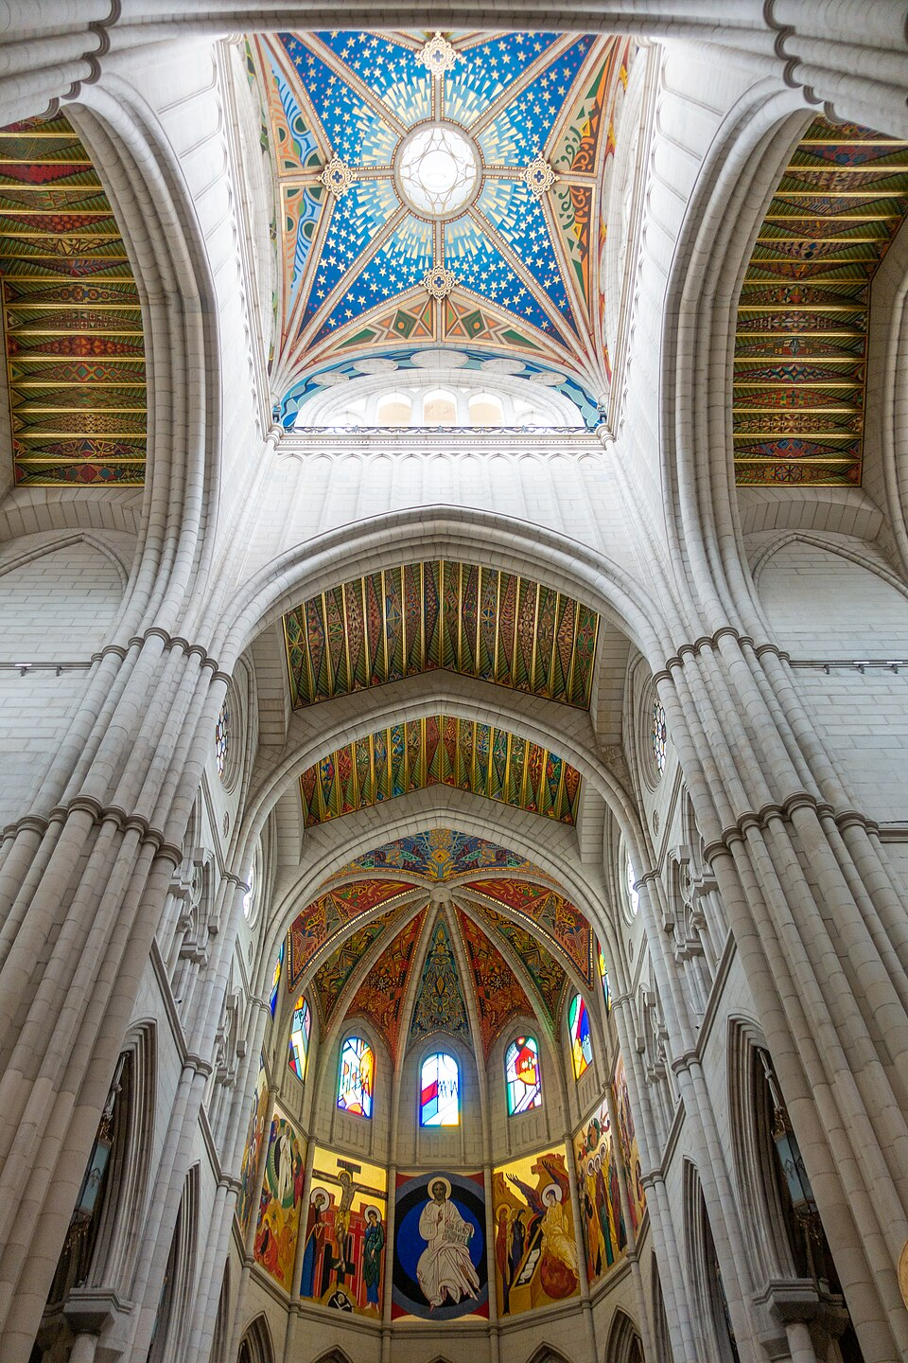

*The Neo-Revivalist Almudena Cathedral in Madrid seems to have found a modern expression of Spanish culture and Christian history, containing a very classic shell and design language alongside stained glass that nods stylistically to one of the country’s most famous artists, Picasso, as well as the ongoing presence of Christian faithfulness in a new age.*

From [*Wikimedia*](https://upload.wikimedia.org/wikipedia/commons/thumb/b/ba/Almudena_Cathedral_%2851906894722%29.jpg/960px-Almudena_Cathedral_%2851906894722%29.jpg)(Kent Wang, 2022). Creative Commons.

The theory and practice of liturgical arts has and should be the topic of whole courses, books, conferences, lectures, etc. This amount of time and space will be insufficient to cover all the different Christian traditions and their perspectives on what kinds of art should be allowed in places of worship, what sacraments should be celebrated or given the most attention or artistic focus, which liturgical form to follow, how the church’s architecture should feature into our experience, etc. This time will be used to think about a few broad-stroke concerns that can initiate us into this whole world of thought.

#### 1. Liturgy is formative:

There are all manner ways acts of worship can be set up, and indeed perspectives on where worship ‘ends’. Is all of life a kind of liturgy? Those in the [Quaker tradition come to a simple ‘meeting house’](https://quaker.org/how-do-quakers-worship/), and often sit in intentional silence in a circle in order to demonstrate that the Spirit may move anyone equally. By strong contrast, worshipers in traditions like Eastern Orthodoxy, Roman Catholicism or high church Anglicanism (among others) will arrive to buildings of varying degrees of ornamentation in which the main worship space has a cross shape to it, with an altar near where the two planes cross. Worshipers in this scenario line up in parallel pews, with their gaze and attention often directed toward the clergy at the front. There are other forms, of course, but this stark difference serves to demonstrate that we all implicitly believe *how we worship forms who we become as worshippers.* Lay aside preferences and judgments for a moment and consider what your tradition or another is trying to suggest by the physical layout of its worship spaces. ‘Liturgy’ as a broad concept matters for us, because it deals with expression of our theologies and beliefs in a broadly non-conceptual way. Certainly, each of these ways of doing something is backed by a library of theological discourse about why it is important to worship in that way, but we ‘meet’ those ideas first (in the case of infancy) and primarily (in the case that most members of the church do not read its theoretical literature) through our senses.

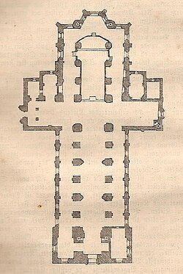

*Floorplan from Cathedral of Aarhus, Denmark.*

From [*Wikimedia*](https://upload.wikimedia.org/wikipedia/commons/thumb/7/76/Cathedral_of_%C3%85rhus_floorplan_1879.JPG/250px-Cathedral_of_%C3%85rhus_floorplan_1879.JPG). (Sten Porse, 2008). Creative Commons.

There is a reciprocal relationship between what we desire and how we behave, philosopher James K. A. Smith argues (Smith, 2009). You are not ‘what you eat’, nor does ‘what you eat’ have nothing to do with your quality of life. In the same way, your desires and intentions will never be fully expressed by your tradition’s style of worshipping, nor will how you worship have nothing to do with your understanding of what God is like, how we believe we ought to live, etc. Church teaching and Christian education, Smith argues, cannot be limited to simply ‘info-dumping’ the correct views about something, but is rather an opportunity to shape who the believer is and how they desire to live. The creation of desire begins from the very (literal) foundations of our buildings and then leads through all aspects of the service itself.

“The architecture of the building has a recognizable code that makes us feel at home in any city. The large glass atriums at the entrances are framed by banners and flags; familiar texts and symbols on the exterior walls help the foreign faithful to quickly identify what’s inside... As we enter the space, we are ushered into a narthex of sorts intended for receiving, orienting, and channeling new seekers as well as providing a bit of decompression space for the regular faithful to ‘enter in’ to the spirit of the space...the design of the interior is inviting to an almost excessive degree, sucking us into the enclosed interior spaces, with windows on the ceiling open to the sky but none on the walls open to the surrounding automotive moat [the parking lot]. This conveys a sense of vertical and transcendent openness that at the same time shuts off the clamor and distractions of the horizontal, mundane world.” (Smith, 2009, 20)

Architecture sets the stage for what is about to happen in the space, in terms of both devotion and hospitality. The same is true for the Quaker meeting. Although differently expressed in each circumstance, intentions are set and shown at a sensory or physical level, suggesting what is possible for us and for the way God greets us. Is the God you meet in worship loving, gentle, passionate against injustice, etc., or docile, sterile, and cold? In your church building, do you meet a God who greets all people with arms wide, the building beckoning you to belong and adore, or is a secondary element in the service, a quiet mystery knowable only by a few? (Any tradition and style can do this well, by the way). The same is true for every other element of the service: communion and how it is served, the music, the order of events, the decoration on the walls, and style of and reverence for the communion paraphernalia, where we sit and what we sit on, how scripture is read, who reads it, etc. We take these things for granted, but they represent a lot of both imagination and careful attention, for in the scriptures we receive very little by way of specific guidance about how our churches and liturgies are meant to be set up. To set up a church and a church service means faithfully apprenticing oneself to the God of scripture and how God, the Son, and the Holy Spirit meet us, and a lot of creativity to fill in the blanks.

Smith argues that we are liturgical creatures by nature: we want to set up patterns of behavior that express our deepest meanings and our deepest yearnings. We also have cultural liturgies, he suggests, such as the pedagogies that underpin different styles of education children or parenting them, habits of going about your day, or the way that people typically behave at shopping malls. (Smith, 2009, 27) They express eternal and intangible desires, but we interact with them at the level of routines, physical movements, sense perceptions, and the objects that occupy our spaces.

#### 2. This leads us to our second point: Valuing liturgy treats the human as a whole self.

If a worldview is too narrowly understood as a set of beliefs we consciously agree to, which are ultimately considered more important than the ‘little ways’ we express those beliefs, it

“reduces Christian faith primarily to a set of ideas, principles, claims, and propositions that are known and believed...they tend to assume a distinction between our souls and our bodies – and then tend to ignore our embodiment (or wish it weren’t there). But what if our bodies are essential to our identities?” (Smith, 2009, 32)

Smith argues that following Jesus is more about becoming “the kind of person who *loves* rightly” and not about “getting the right idea and doctrines and beliefs into your head in order to guarantee proper behavior.” (Smith, 2009, 32) That would be religious legalism, as is the fear that some part of how humans are naturally created to be (embodied, sensing people) is a detriment to meeting God and needs constant control and vigilance. Put differently, why would God create us to enjoy and be moved by the sensory experience of something like worship, if we were not supposed to learn about God in that manner? So while it is possible to make too much of liturgy (‘it’s my way or the highway, no one can come to truly understand God if they don’t worship exactly as I do’), it is also possible to ignore how liturgical arts can make us feel and that it is part of God’s design for worship. “The liturgy is a ‘hearts and minds’ strategy, a pedagogy that trains us as disciples precisely by putting our bodies through a regimen of repeat practices that get hold of our heart and ‘aim’ our love toward the kingdom of God.” (Smith, 2009, 33) Quite simply, valuing the liturgy in what every form it takes in your church, or advocating for artists to involved in making worship a time of delight, helps to treat the worshiper as a whole person and not just a brain on legs.

Recall the model of ‘disinterestedness’ that Kant promoted (see Unit 1); things that are truly beautiful will have universal appreciation and have nothing to do with personal preference. Worship seems to be exactly the sort of human activity that is not supposed to be approached in a disinterested fashion! Enjoying worship in your body or senses, having favourite hymns, feeling God’s presence for yourself in certain times or in certain kinds of buildings, experiencing delight in a uniquely personal way, these all must feature in our experiences of ecstasy in worship. In the book of Luke, we see some disciples of Jesus talk with him on the road to Emmaus, unaware that the person they are talking to is, in fact, Christ. Later, when Jesus reveals himself, “They asked each other, ‘Were not our hearts burning within us while he talked with us on the road and opened the Scriptures to us?’” (Luke 24:32, NIV). Does it seem like being in God’s presence is meant to be experienced in an intellectual, cool, calm and collected fashion all the time? No!, these disciples characterize the evidence of Jesus’ presence in *physical terms,* as hearts burning*.*

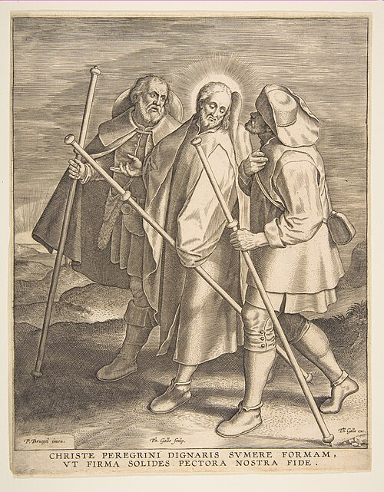

*Pieter Brueghel the Elder, Christ and the Disciples on the Way to Emmaus, 1571.*

From [*Wikimedia*](https://upload.wikimedia.org/wikipedia/commons/thumb/f/f4/Christ_and_the_Disciples_on_the_Way_to_Emmaus_MET_DP818260.jpg/500px-Christ_and_the_Disciples_on_the_Way_to_Emmaus_MET_DP818260.jpg). (Pieter Breghel the Elder, 1571). Creative Commons.

Paintings in church used to be a way of teaching the body of Christ about Christ in a time of illiteracy. This cannot be confused for intellectual poverty; just because more people can read Scripture for themselves does not mean that the primary way of experiencing Christ must be intellectual. Many people will not become theologians, and if one feels more moved by hymn singing than spending their spare time reading treatises, it says absolutely nothing about their intelligence, just that God designs us to delight and worship in many ways, ways that we have been too slow to value in those same treatises.

#### 3. We can support Christian artists by involving their efforts in the creation of liturgies and liturgical arts and in Christian led-spaces, or we resign them to only show their gifts in ‘secular’ spaces.

This is a simple one: if we do not support Christian artists, where will they go to find work? In the next topic we will discuss the merits and draw backs of institutions like museums as supporters of art. If churches are unwilling to both affirm art as a vocation and support artists financially, it means that so-called secular spaces are doing more to support artists than the churches meant to recognize their gifts. It is not wrong for Christian artists to seek out work outside the church: we do not need to return to the medieval model of churches being the only benefactors for fine artistry. However, we must acknowledge that if churches and individual Christians are not being giving encouragement and resources, we are letting others be better champions of that God-given talent. Artists approach subject matter with imagination: we still need the perspectives and vision of Christian artists as companions in our modern times, for encouragement and exhortation through the senses, precisely because we are embodied people (see point 2). Remember Calvin Seerveld’s assertion that Christian art will involve a relevant and renewed response to the brokenness of our world, saying Christian art is like breathing fresh air (Seerveld, 2000)? How can we gain that perspective solely through artworks made in other time periods? We can either recognize the ongoing necessity of having artists create liturgical art, or lose out on their Christian ‘witness’.

### Gallery

Unit 3.2

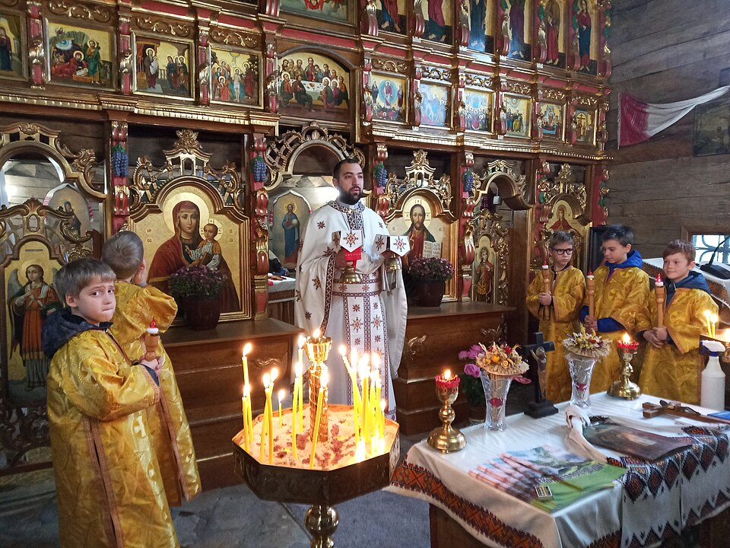There are many so-called ”High-Church” traditions of liturgy, ones that value and prioritize the sensory element of the sacraments and other activities that take place during a service.

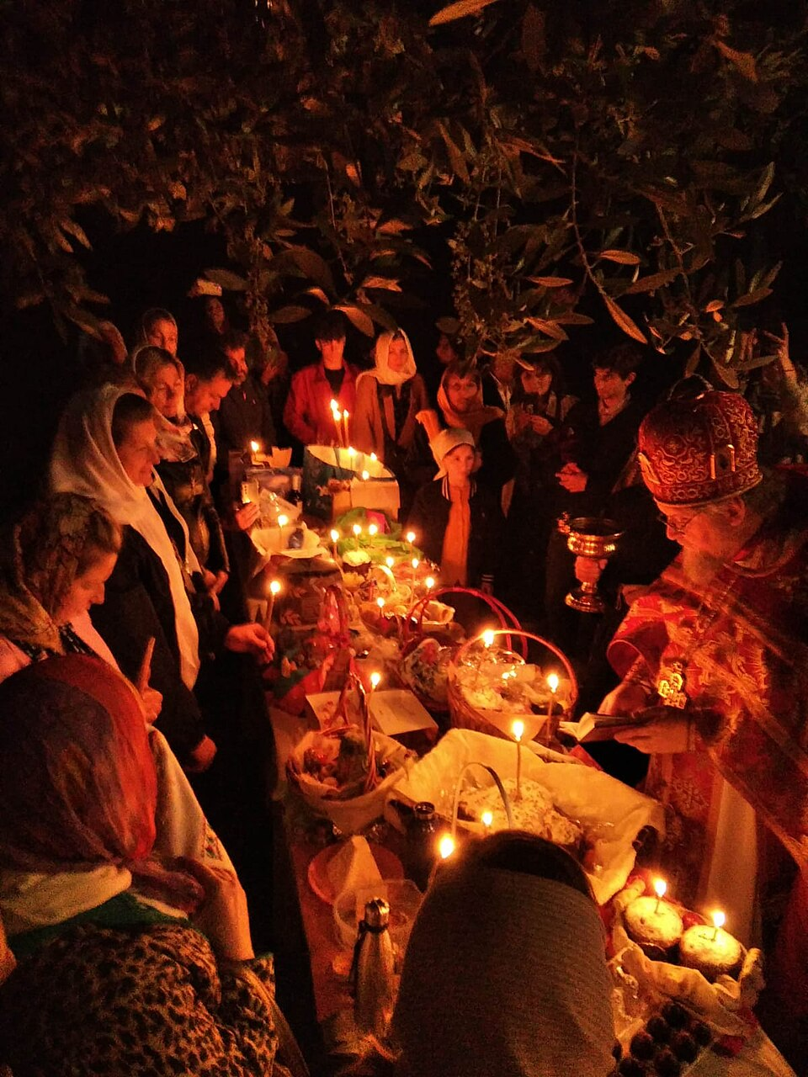

How do the celebration of festivals and holy days change the aesthetic experience of your faith?

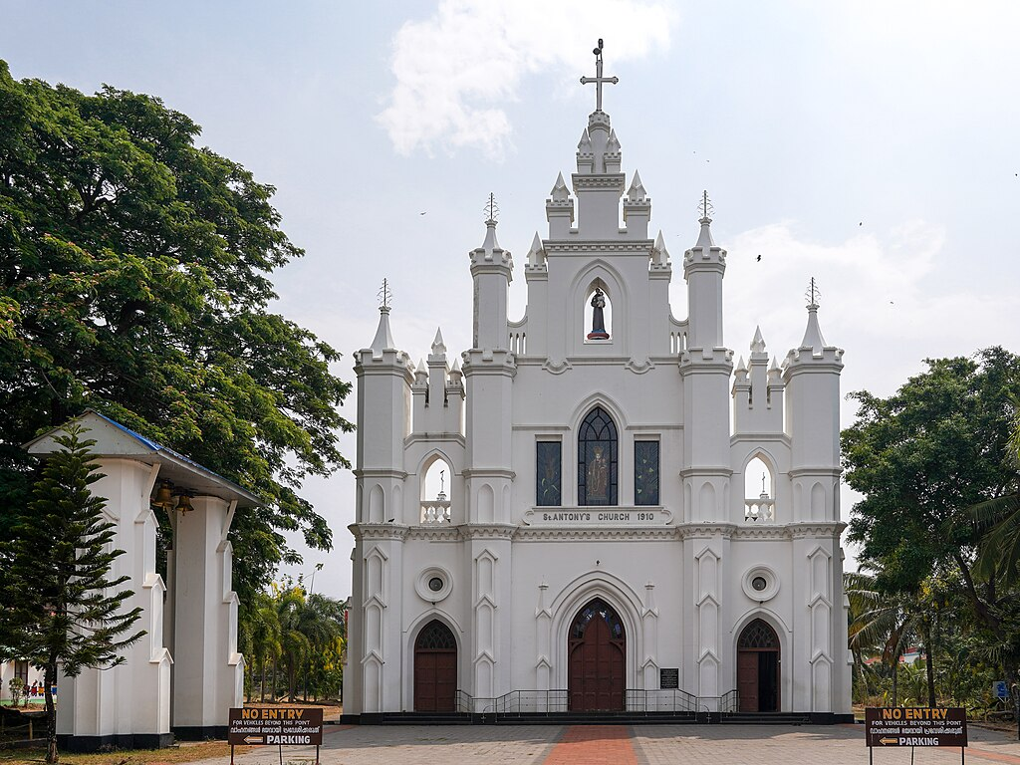Churches around the world develop ’vernacular’, local styles of church design that reflect not just a continuity with historical Christian style, but (ideally) show something of the local environment and sense of place. This church is in Kerala.

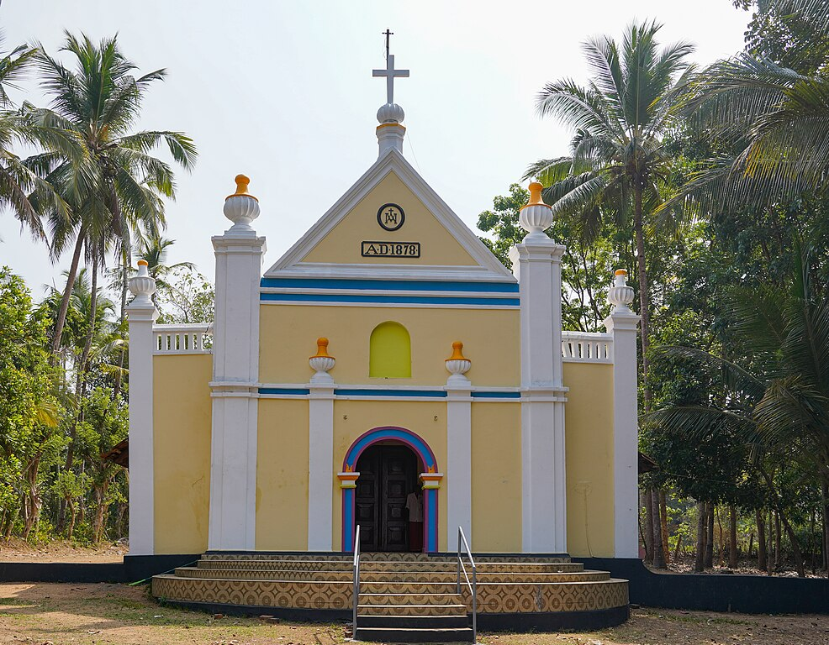

This church is also from Kerala.

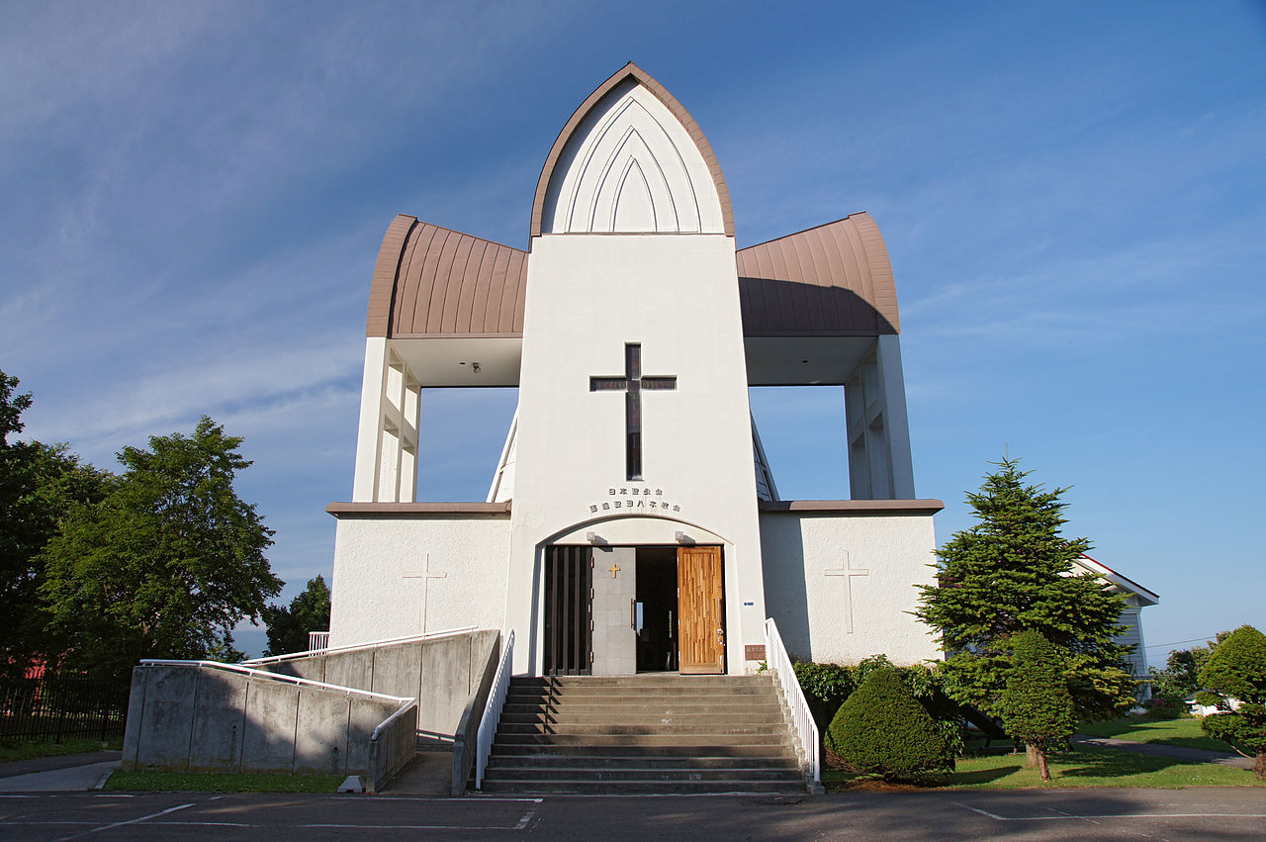

A church in Hokkaido, Japan.

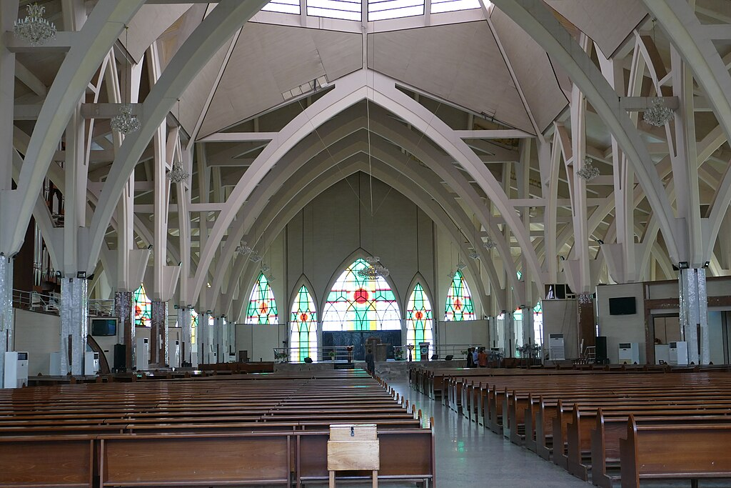

Interior of a church in Abuja, Nigeria. What are the benefits, limitations of having recognizable church style in different parts of the world. How might churches in different countries reinterpret the floorplan to suggest something about God’s history with their people?

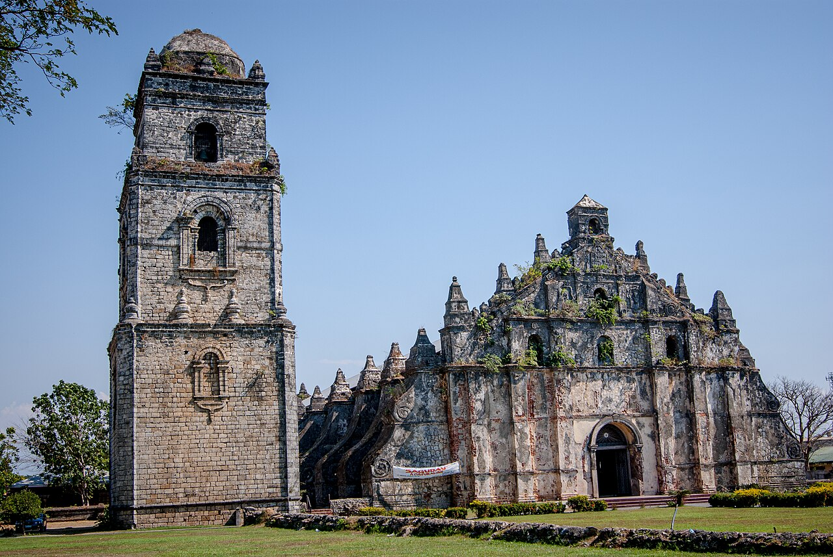

Baroque Church in Ilocos Norte, Philippines.

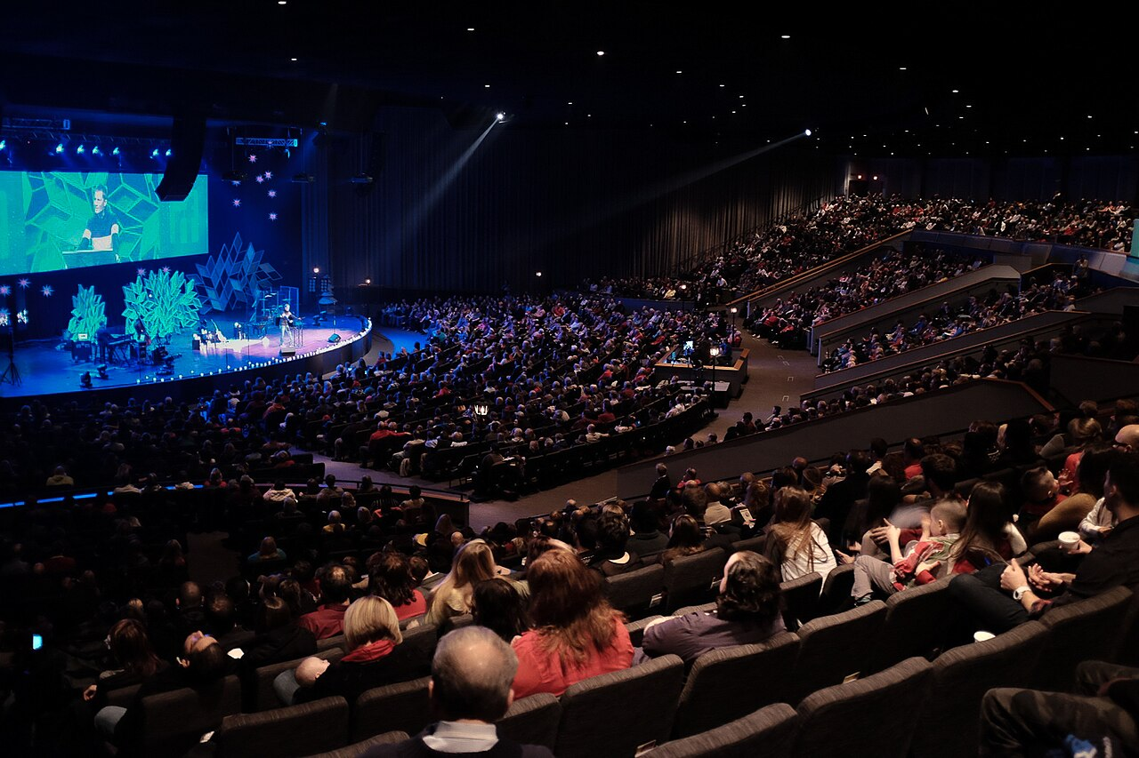A ‘MegaChurch’ in the United States.

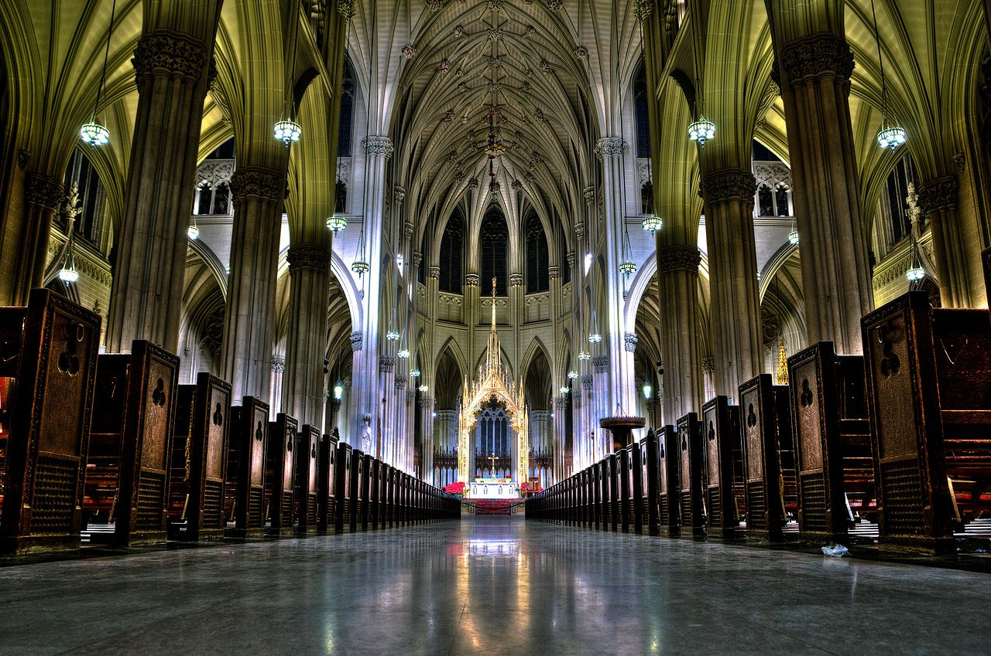

A Cathedral in New York City.

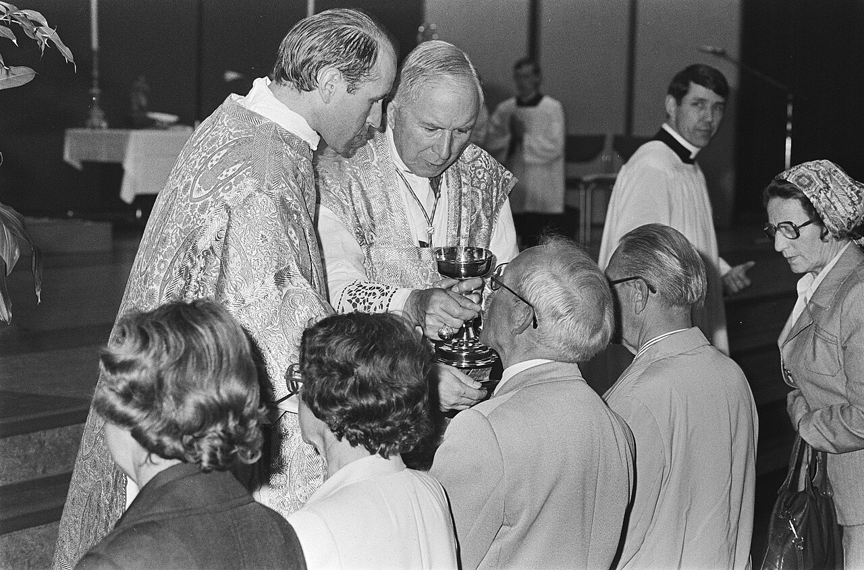

How do you take communion in your church? Do you go forward to receive it? Kneel? Stay in your seats and pass a plate? Is the bread tasty, is it real wine? Is it only an ordained person that can handle the elements, or do deacons/elders/lay people help with serving?



What sort of chalice holds communion wine?

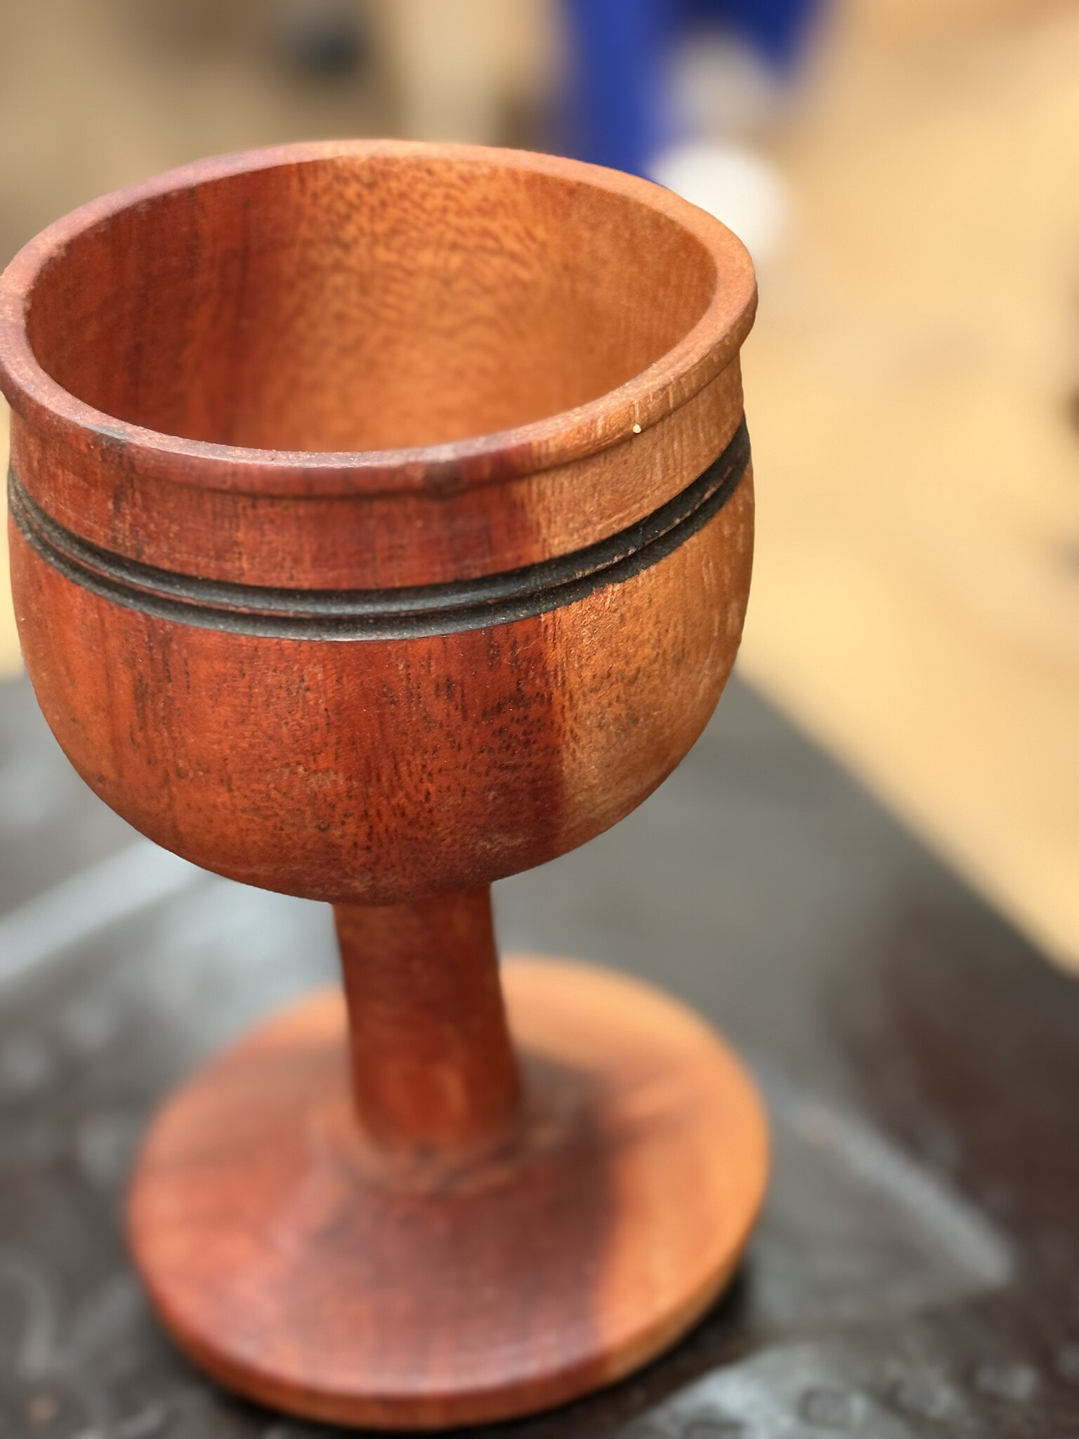

Is a simple chalice more ‘Christlike’ because it’s closer to what Jesus used at the last supper? What are the limitations and blessings of using ornament to celebrate and elevate in our imagination what was initially a very unfussy ritual of sharing a daily meal

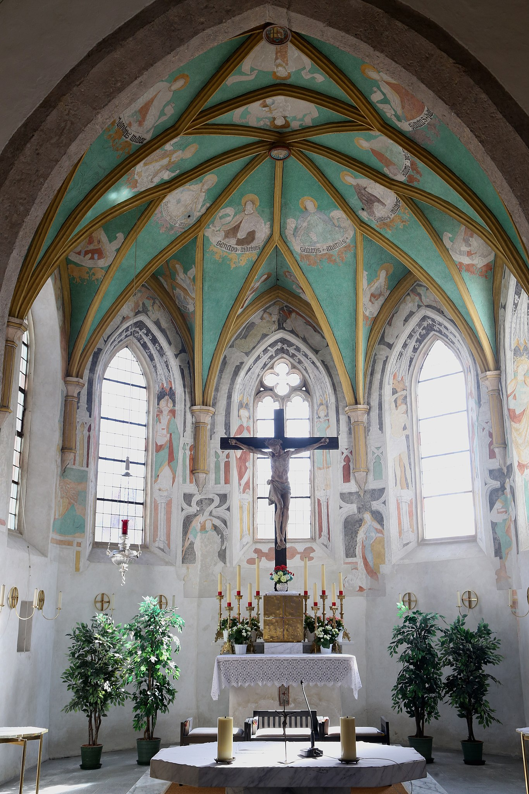

Regardless of tradition, think of your specific and local church: is it well lit, is it moody, lilting and gracious or foreboding and contemplative in its decoration? Is colour used either to set the mood or symbolically?

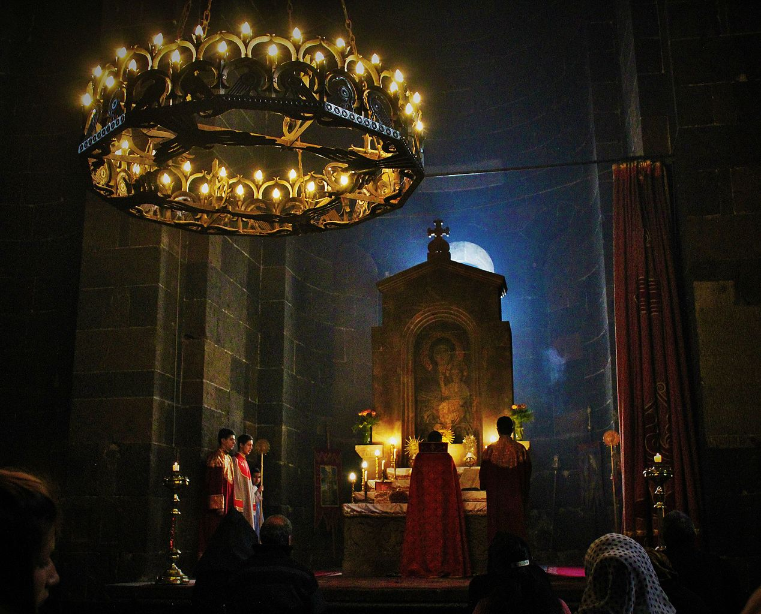

What might you feel about God if this is where you prayed each week?

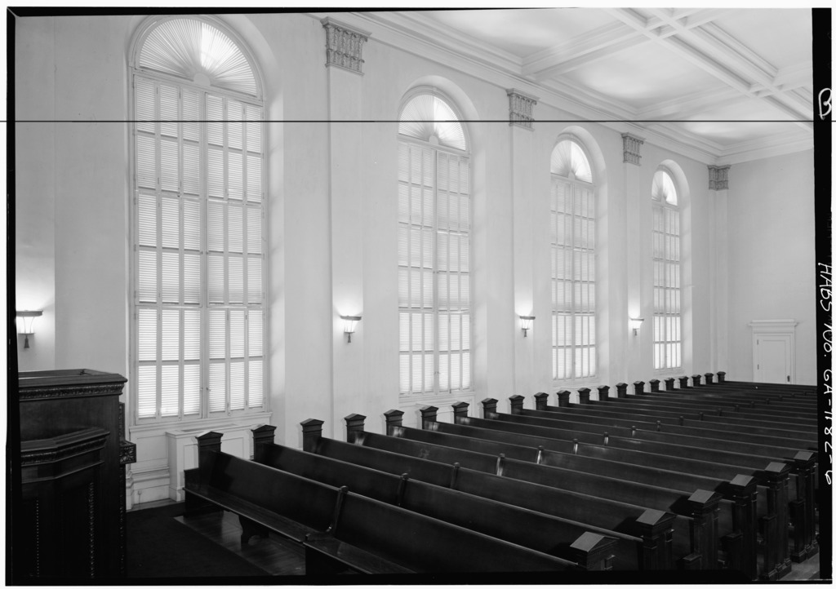

What about in this one?

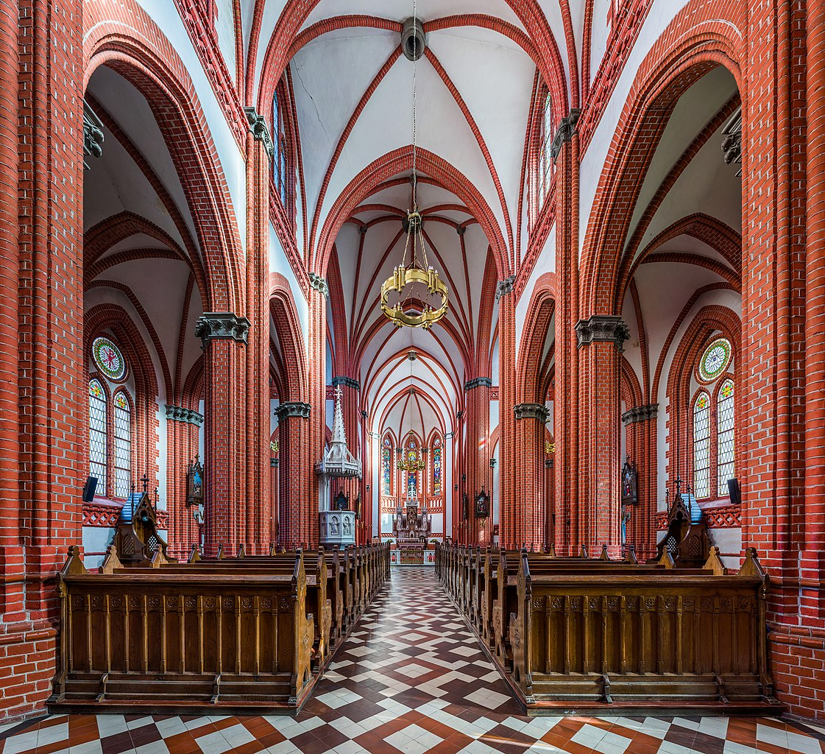

In this one?

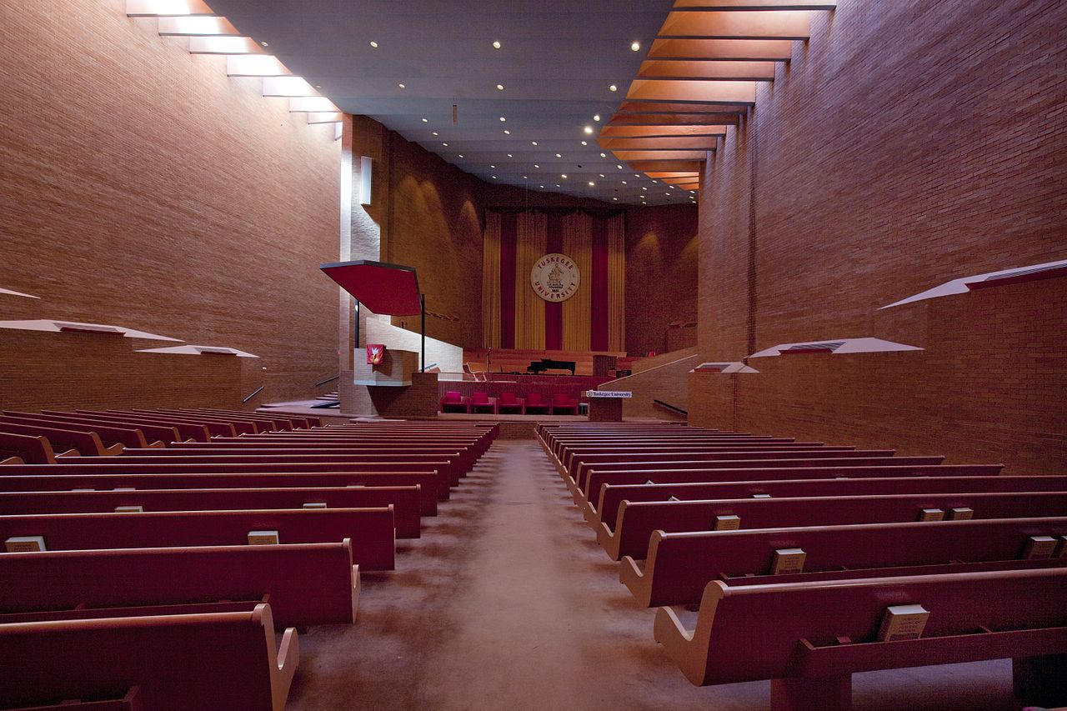

In here?

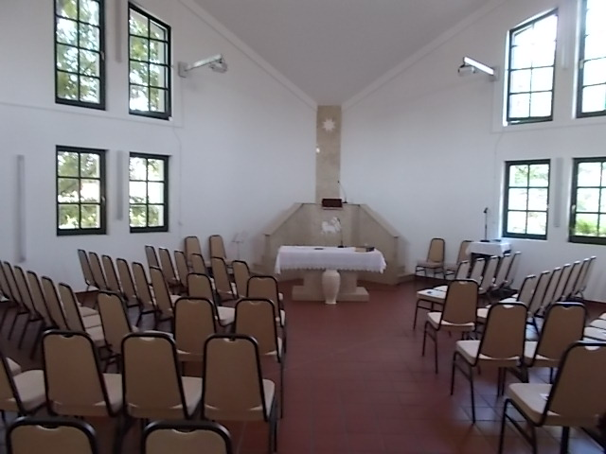

Or in this one?

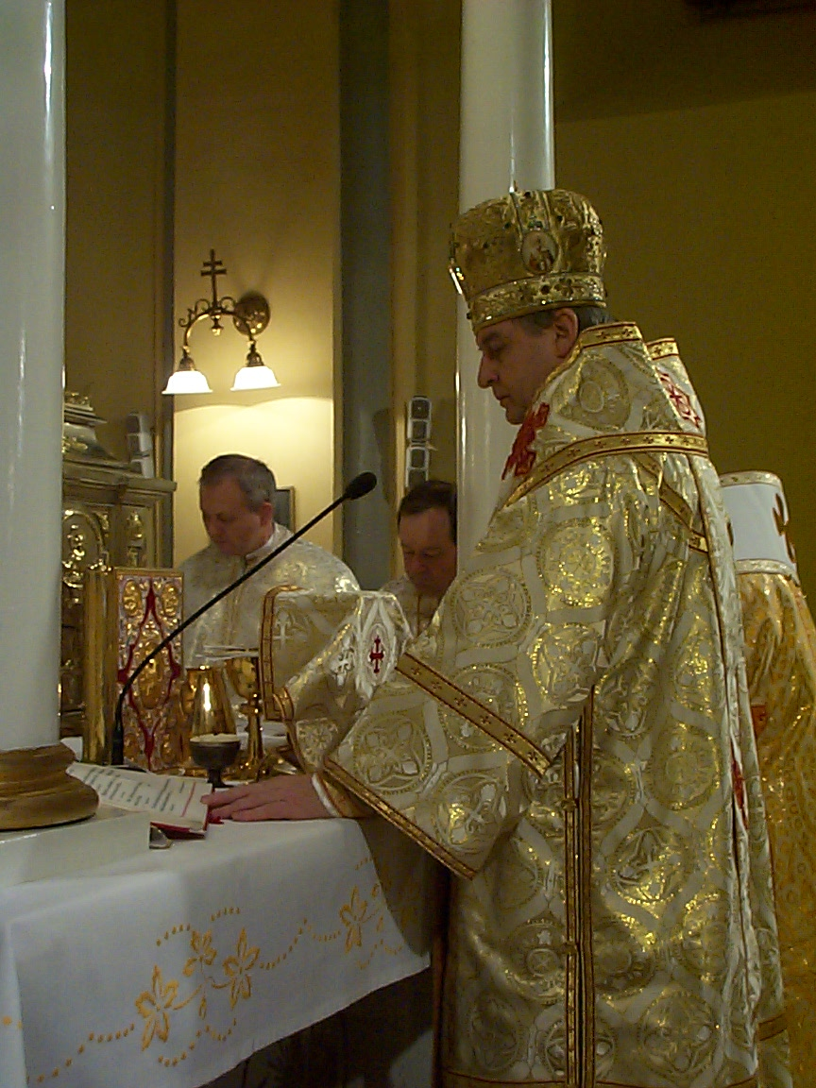What do people wear?

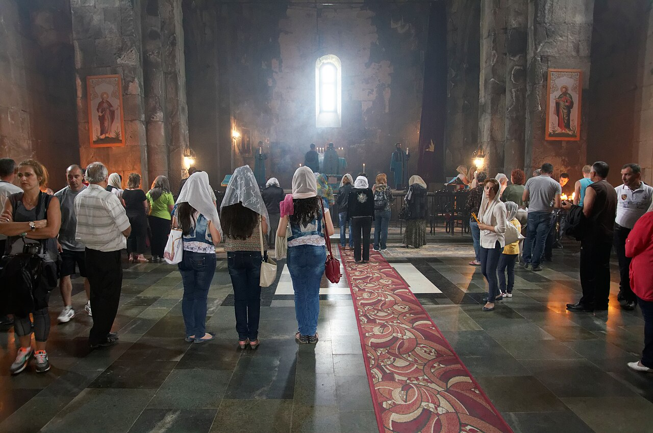

What do you wear? What do people typically wear when attending? Is there a dress code? Think about how people might figure out what to wear even if there is no state or published dress code. Where do we get our cues, what do we value in the act of getting dressed?

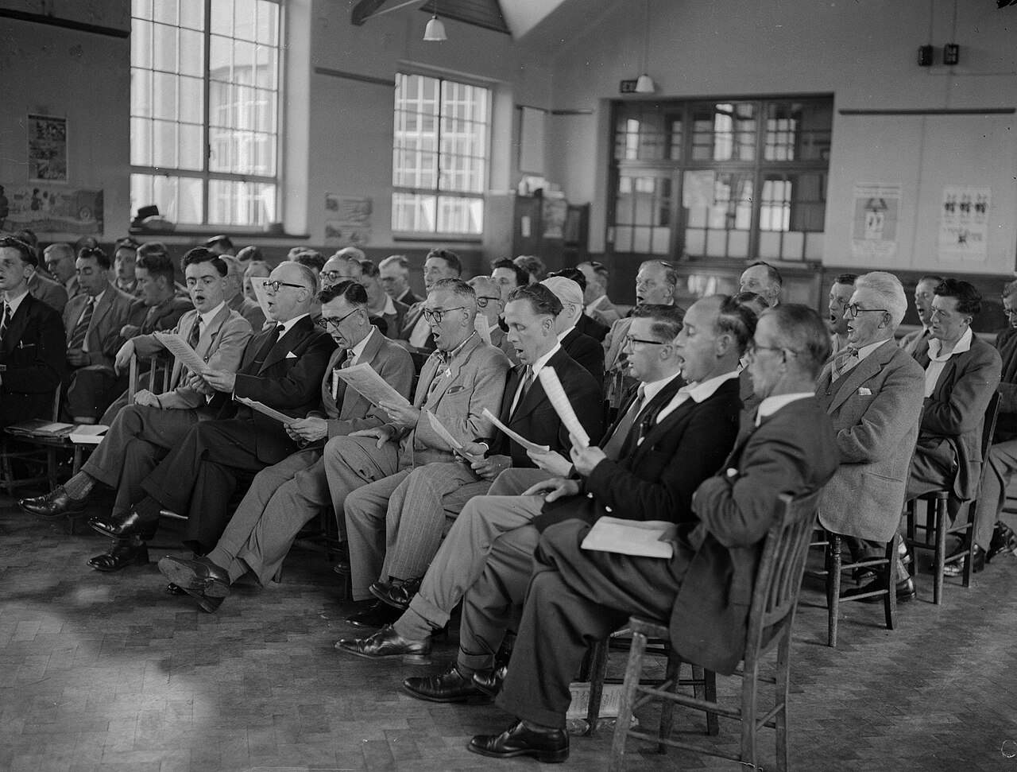

[Do you have a concept of “Sunday Best”? Do you dress up for holidays?]

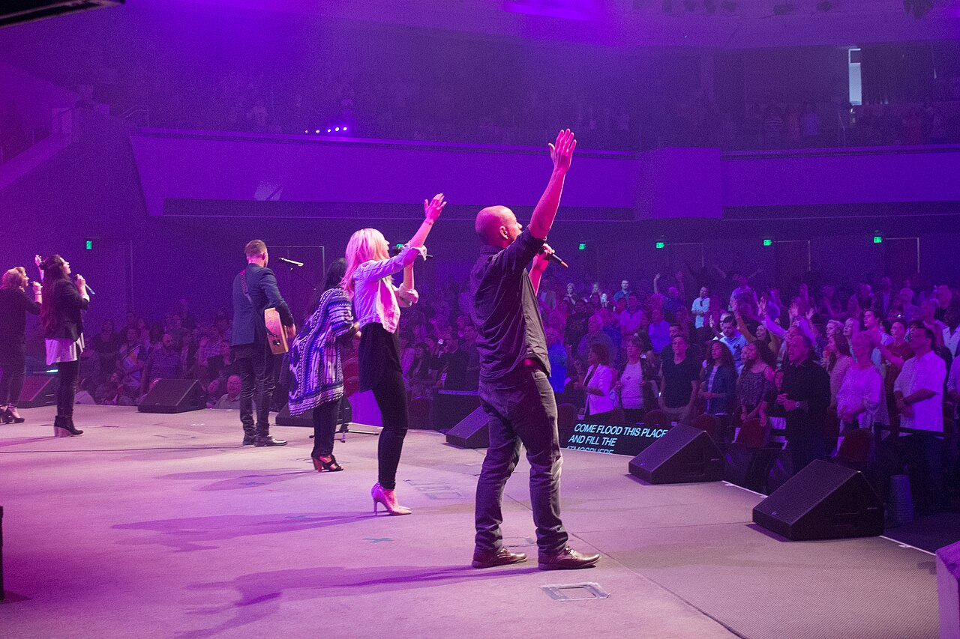

[How do you sing praises to God?]

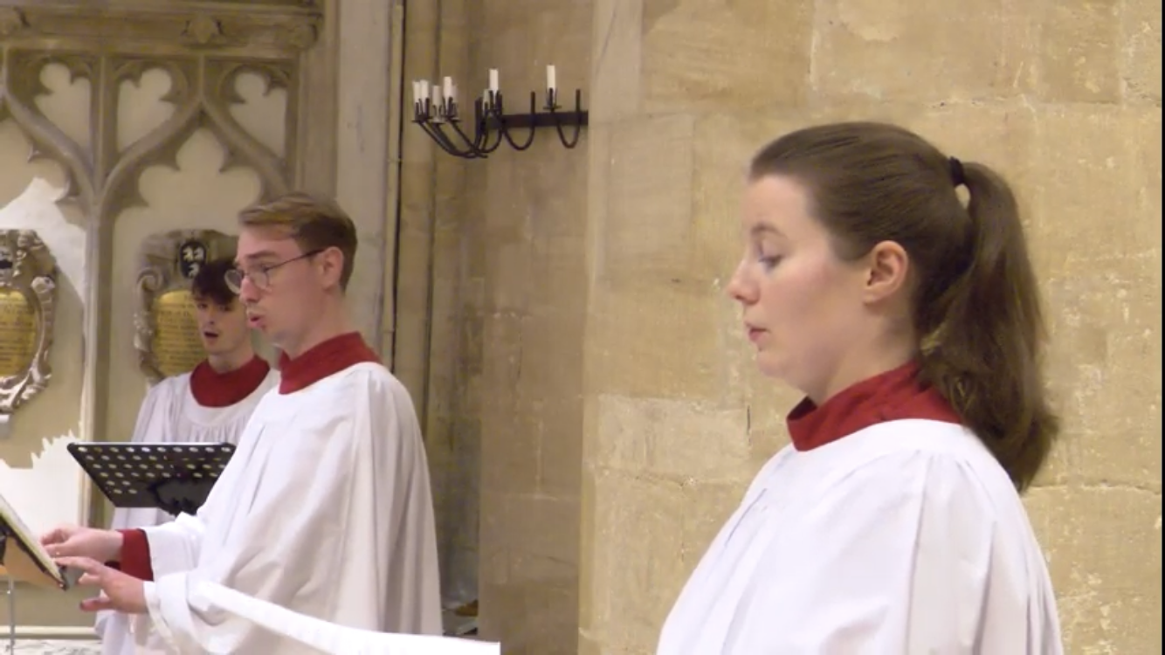

[Do you have an organ, a choir? How do the choir dress? Why? What do this image and the last one each declare they value? Hint: informal worship styles are normally meant to emphasize a democratic ‘come as you are’ feeling, while more ornamentation/celebration is usually focused on celebration of the spiritual or focus on the sacred among the daily/mundane. How do we judge between these two emphases and the virtues they each prioritize expressing in their style?]

### Activity: Pentecost and the Holy Spirit - Visual Art in Churches

**<Begin learning-activity>**

**Estimated Time: 5 mins**

Learn about some examples of contemporary Christian art installations in church. This article shows 4 examples of art produced around the topic of the Holy Spirit and Pentecost:

* **Read:** [*Four site-specific art installations in churches for Pentecost*](https://artandtheology.org/2025/05/30/art-installations-churches-pentecost/)by Victoria Emily Jones (*Art & Theology,* 2025).

**Questions to Consider:**

* Did any of these ‘speak’ to you more than the others? Why do you think that is?
* How did these contemporary installations ‘play’ with the traditional ways of using space or of decorating churches for worship? In what ways do you think they were successful (or not).
* Can you think of one of these installations that would be most appropriate for a space you regularly worship in or are familiar with? Why is it most appropriate? Would others from that community agree? Is consensus important?

**<End learning-activity>**

### Activity: Be a Stranger in Your Own Space

**<Begin learning-activity>**

**Estimated Time: 5 mins**



*A well lit office space cheered up with plants, wood tones, and funky lighting.*

From [*Wikimedia*](https://upload.wikimedia.org/wikipedia/commons/thumb/d/d8/Office_space_oxford_street_fitzrovia_office_space_for_hire_20_desk_office.jpg/960px-Office_space_oxford_street_fitzrovia_office_space_for_hire_20_desk_office.jpg) (Lydia Jane Lewington, 2022). Creative Commons.

In your mind, take a few minutes to think about what you would learn about your church by attending a service there as a stranger?

Have you ever visited a different religion’s place of worship? Would you have a different work or school experience if the activities were held in a different building?

**Questions to Consider:**

* Bonus: Take notes in a reflective journal about what stood out to you, and discuss with someone else who knows the space. If taking class synchronously, be prepared to share your unique experience of a place in class discussion.
* What do you think this community or institution values, based solely on the sensory experience or physical space where the activities happen in?

If you are thinking of a church or other religion’s faith community, be specific about what their space suggests to you about how they see God or worship.

* Were there any sensory elements that you realized contributed to your experience there even if you did not pay attention to them before? (e.g., incense, music, lighting, chalk dust (school), etc).
* Have you been in a community or institution where the ethos or social experience felt at odds with the visual, auditory, etc cues?

For example, a decorated space lacking in social warmth or a sparse place that felt socially warm?, an office building that was depressing yet the leadership managed to be calm and approachable. How would a change of sensory context change your experience of that community or how people behaved in it?

**<End learning-activity>**

### Activity: Art and Christian Community

**<Begin learning-activity>**

**Estimated Time: 45 mins**

**Mandatory Watch:** In this lecture, hear more from John Skillen as he discusses what church art has meant to congregants over the centuries. He references Wolterstorff’s research on work songs as a related extension of the same idea: that art serves an instrumental purpose in encouraging and uplifting communities of faith. What role does the art and style of building play in how they worship there, and what they are told is important for believers? What does your place of worship tell you is important and praiseworthy? Does it say anything? This will help you consider the formative way that aesthetically designed things and spaces transform our church lives, which should help you reflect upon the things in spaces in your own life for the “Personal Aesthetic Audit” project.

**Watch:** [*John Skillen: Art and Christian Community - Anselm Society*](https://www.youtube.com/watch?v=1UDWWUMEOBE) (Anselm Society, 2019)

<https://www.youtube.com/watch?v=1UDWWUMEOBE>

**<End learning-activity>**

### Activity: What do Liturgy and Liturgical Art offer?

**<Begin learning-activity>**

**Estimated Time: 60 mins**

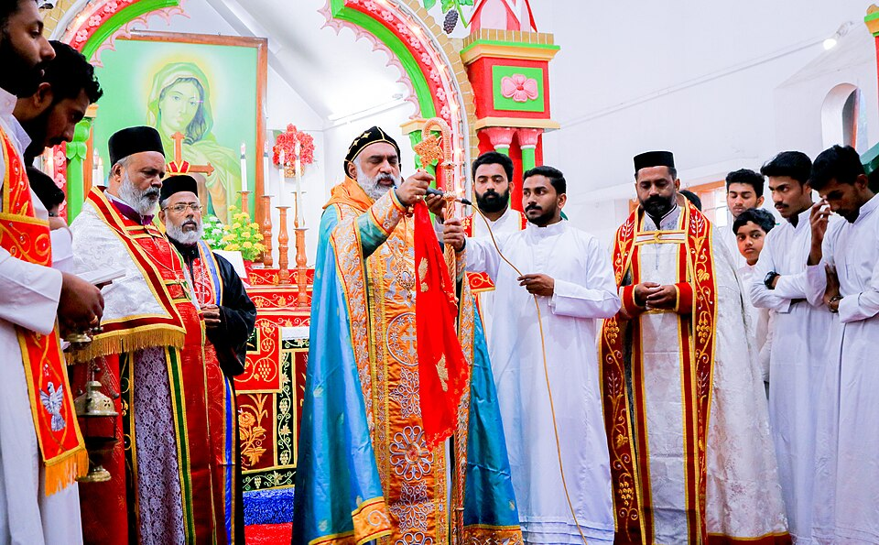

*Catholic service in Kerala, India.*

From [*Wikimedia*](https://upload.wikimedia.org/wikipedia/commons/thumb/d/d9/Eucharist_at_St._Mary%27s_Church%2C_Meenangadi.jpg/960px-Eucharist_at_St._Mary%27s_Church%2C_Meenangadi.jpg)

**Mandatory Reading/Listening:** Hear from some different perspectives of what liturgical arts can be or can offer those with varying degrees of relationship to churches. Together, these perspectives show that the benefits of including an aesthetic dimension of liturgy can show up in many different forms (as a work of justice or compassion, a means of connecting with God, others, or one’s history, as a reminder to act Christianly during the week, as an invitation to people of other/no faith background.) This exercise should help you to think about the same phenomenon (liturgy) from several different perspectives. In the same way, course assignments will ask you to consider your own aesthetic experiences through various lenses, so this is good practice.

* **Read:** “[Power and Protest: A Christian Liturgical Response to Religious Trauma”](https://mytwu.sharepoint.com/sites/LearningDesign/Shared%20Documents/Forms/AllItems.aspx?viewid=40cf7fb5%2D2131%2D4adc%2Dbd1e%2D88296482bfbb&id=%2Fsites%2FLearningDesign%2FShared%20Documents%2FSAMC%20Doc%2FSAMC%20I%20PHIL%20370%2F2%2E%20Units%2FReading%20Files%2F3%2E2%20Michelle%20Panchuck%20Power%20and%20Protest%2Epdf&parent=%2Fsites%2FLearningDesign%2FShared%20Documents%2FSAMC%20Doc%2FSAMC%20I%20PHIL%20370%2F2%2E%20Units%2FReading%20Files) (Panchuk, 2023), pp. 77–93 (PDF).

This chapter aims to think about ways that Christian tradition can speak redemptively to a current and widespread hurt. Be forewarned: it deals with topics like religious trauma and sexual violence, but does so sensitively and starts from the belief of survivor testimony.

* **Read**: [*Liturgical arts: do they serve as a source of worship beyond the church walls?*](https://pres-outlook.org/2023/11/liturgical-arts-do-they-serve-as-a-source-of-worship-beyond-the-church-walls/)This is a brief conversation from The Presbyterian Outlook
* **Read:** [*“Lex Orandi: Liturgical Arts As Visible Signs and Expressions of Continuity”.*](https://www.liturgicalartsjournal.com/2022/06/lex-orandi-liturgical-arts-as-visible.html)

This article from the Catholic-focused Liturgical Arts Journal, demonstrates well that liturgical art and architecture can be a ‘wide’ door to share the faith, while formal theology is a ‘narrow’ door because only some people are inclined to read books by theologians like St. Thomas Aquinas. At times, the point is well made but sloppily done; it is accidently suggested that the group of Japanese tourists fawning over the beauty of Notre Dame Cathedral in Paris require evangelism which that beauty can provide, but it should not be presumed that those same tourists are not already Christian or that they are spiritually lacking in some way.

* And finally, watch this short video from an Orthodox artist discussing what a common design language between churches in different parts of the world offered him as a believer.

**Watch:** [*What Does Orthodox Christian Liturgical Art Have to Offer the West?*](https://www.youtube.com/watch?v=Ryvdxz1rl_k) (Protecting Veil, 2018)

<https://www.youtube.com/watch?v=Ryvdxz1rl_k>

**Questions to Consider:**

* Did any of the opinions about what liturgy is or offers make you uncomfortable, and why?
* While recognizing that each person does not speak as a representative of their tradition as a whole, did you discern different emphases between speakers/writers?
* What are some ways that liturgy and liturgical art and design have shaped your experience that were not mentioned in these articles or video?
* Which ideas were most and least convicting to you as arguments?

**<End learning-activity>**

## Museums and Institutions

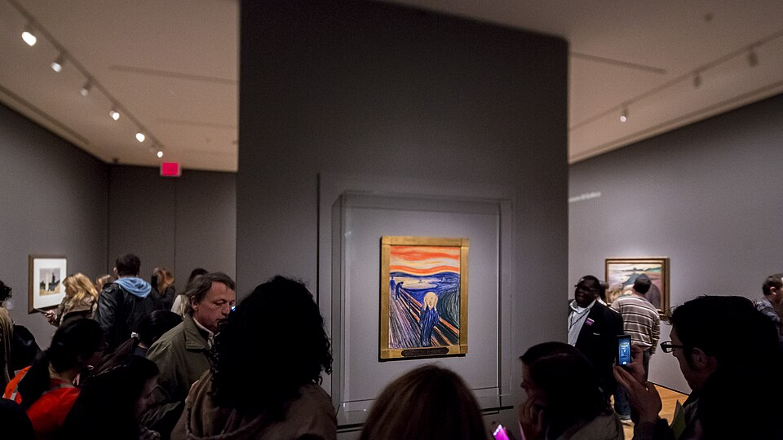*Edvard Munch’s The Scream on display at MOMA.*

From [*Wikimedia*](https://upload.wikimedia.org/wikipedia/commons/thumb/c/c3/Edvard_Munch%27s_The_Scream.jpg/960px-Edvard_Munch%27s_The_Scream.jpg) (Parker Miles Blohm, 2013). Creative Commons

Where should Christians sell and display their art, and where should Christians go to experience art? There are few straight-forward answers and - like many topics in this course – it involves creating a rubric for discernment.

In one sense, the tight association between fine arts and the institutional model of support for fine arts (the museum and gallery) sets up a limited relationship between the work of art and the viewer. Art is primarily meant to be contemplated in such spaces, with a calm posture and a good measure of quiet. The gallery space sets the terms of our interaction, and prioritizes (probably unintentionally) a ‘disinterested’ form of engagement with the work of creative people that only represents some small part of what art could mean for us. “Now if one looks at our society’s works of high art one is at once struck by the fact that they are almost exclusively intended, by producer or distributor, for contemplation...The vast diversity of intended use of works of art is here narrowed down to just this one.” (Wolterstorff, ___, 24) We may think this is exactly what we perpetuate when we hang works of art on our walls at home, but in fact the role that art plays in our home life is very different: we rarely play music and then sit and contemplate it with the strict attention we might in a concert venue. “One characteristic feature of our institution of high art is the important role played within it by special seperated rooms and buildings – concert halls, art galleries, theatres, readings rooms.” (Wolterstorff, __, 25) Instead, music at home lifts us, sets the mood for our cooking or study, it accompanies us through our day. So too the visual art in our home changes the way we live in that space. We have selected art because it already means something to us and we wish to have it around to affect us, in both the case of paintings and family photographs. We choose nice pottery pieces from artisanal fairs because we know it will bring an element of joy to our day to feel the piece in our hands. *So close* a focus on the museum model facilities a limitation of our critical vision, in a way that causes us to ignore *all the ways that humans are created to create*. Wolterstorff argues that the aesthetic dimension of our lives is *instrumental*, we make art in order to do something, to cause something for ourselves or others. “Though art for contemplation, especially intellectualized contemplation requires leisure, it should be obvious that leisure is not in general a condition for commerce with the arts. Within the world’s music are to be found work songs.” (Wolterstorff, 1996, 26).

The institutional model for the creation and appreciation of art is not all bad. Just as Christians set up and designate other institutions for different purposes (church, government, school, health care), institutions for art can be an opportunity to recognize the aesthetic aspect of our experience, to support people who feel called to minister to God’s people artistically in the way that people feel called to minister medically or spiritually and the like. Healthy societies seem to support art institutions while unhealthy ones defund (economic pressure) or shutter them (authoritarianism). Whether one feels very interested in the public funding of arts in these large museums or not, it is a reality that one’s tax dollars are already going toward such programs; that is enough reason to be interested. Calvin Seerveld argues that it is not just Christian artists who are needed, but Christian critics and an engaged public too.

“A critic is called to the norm of discerning excellences and testing whether the spirit of the piece be from God or not...And the public who view paintings, play songs, read poetry, glance at advertisements, go to the cinema and wear clothe are claled to the norm of growing up to be sensitive to the differences between what is good and what is evil artistically and of gently correcting those who do wrong.” (Seerveld, 2000, 27)

There is also the fact that much Christian, religious, and humanist art from the past is kept by these institutions. Just as much art in the museum has been taken through acts of colonial pillaging, there is much art in museums that have been removed from their contexts of creation, like communion vessels, ornately carved altars, and altarpieces. Seeing them there, removed from their life of service, means that we see them through different lenses. (For more on this topic, read John E. Skillen’s *Putting Art (back) in its Place,* 2016). Yes, we probably appreciate more quickly the skilled labour that went into preparing them, the carving, metal work, and delicate painting. However, we also loose the experience of them as religious objects. Perhaps these artworks could find other homes, but that is unlikely, and would probably restrict free, public access to the art. Visiting museums, both as adults and children, is part of passing on heritage and tradition as well as a means of exposing ourselves to art created by people whose lives are very different from our own. If institutions of art are here to stay, if they have a rightful place among our other institutions, and if we do not want to see them disappear, the public who engage with the art must care about what happens in those spaces as well. Since it is not simply the content or style of a work that makes it glorify God, but rather the spirit in which it is created, Christians are not exempt from caring about the institutions of fine arts in our culture simply because they are not always the most welcoming or accommodating of overtly religious artists in our day and age.

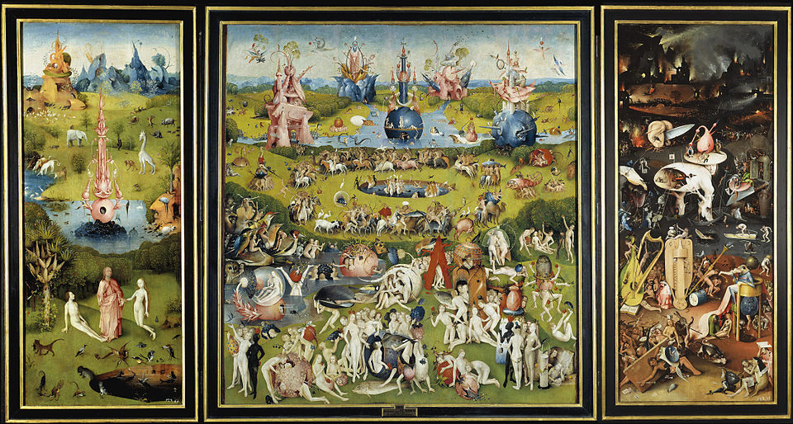*Hieronymos Bosch’s best known work, The Garden of Earthly Delights may have been intended as an altarpiece, given its triptych form, scale, and the obviously Christian imagery. It hangs in Madrid’s Museo del Prado. The context in which we view art changes how we interpret it. In the museum, it is a quirky wonder of colour and strange detail, but the religious nature of the contemplation is lost because of where we go to see it. Nevertheless, it is protected, maintained, and publicly viewable, all of which also matters.*

From [*Wikimedia*](https://upload.wikimedia.org/wikipedia/commons/thumb/b/ba/Garden_delights.jpg/960px-Garden_delights.jpg) (Hieronymos Bosch, 1490-1500). Creative Commons.

There is, however, the very real possibility that some Christianly-minded or Christian-humanist art will not find a home in the larger institutions, both government and private ones, because the message behind the art does not match the spirit of the age. For that reason, Seerveld advocates the creation of artistic spaces intended for Christians, and people of faith or curiosity most generally, where we do not expect the artist to compromise in order to provide for themselves. “A crucial first step must be to unite as a christian organization of artists, based on a statement of faith and a statement of purpose.” (Seerveld, 2000, 33) Seerveld says that setting up Christian galleries is not an isolationist project of retrenching from an impure world, creating one’s own version of something so that one can stay in a Christian bubble. Christian arts projects, as human projects, will be imperfect and lacking in wisdom at various moments. But the benefit of such imperfect ventures (supporting liturgical art, and christian cooperatives and galleries) is two-fold: Firstly, it allows Christians to train and grow in their skills rather than requiring them to be amateurs. “[T]he christian community should plan to support Christians becoming professional jazz musicians or professional short-story writings or professional painters, rather than restricting them to being just gifted amateurs who can turn their artistic hand to many things.” (Seerveld, 2000, 36) Secondly, what Christian art should aim at and what is wanted by the large culture moment may not align, and so institutions of art and artists that are supported both spiritually and financially can provide the opportunity for work and compensation. “Art and all culture worthy of Jesus Christ’s living name must not have the cachet of what is structurally obsolete or be stigmatized by wishful thinking for bygone days. Christian culturing must not produce museum pieces.” (Rainbows, 172) Although Christian art will not be prone to the commercialization and high price point of most gallery art if it is well supported by a Christian community, it may also be unattractive to those same publics if it resists agendas of nostalgia, atheism, etc.

### Gallery

Unit 3.3

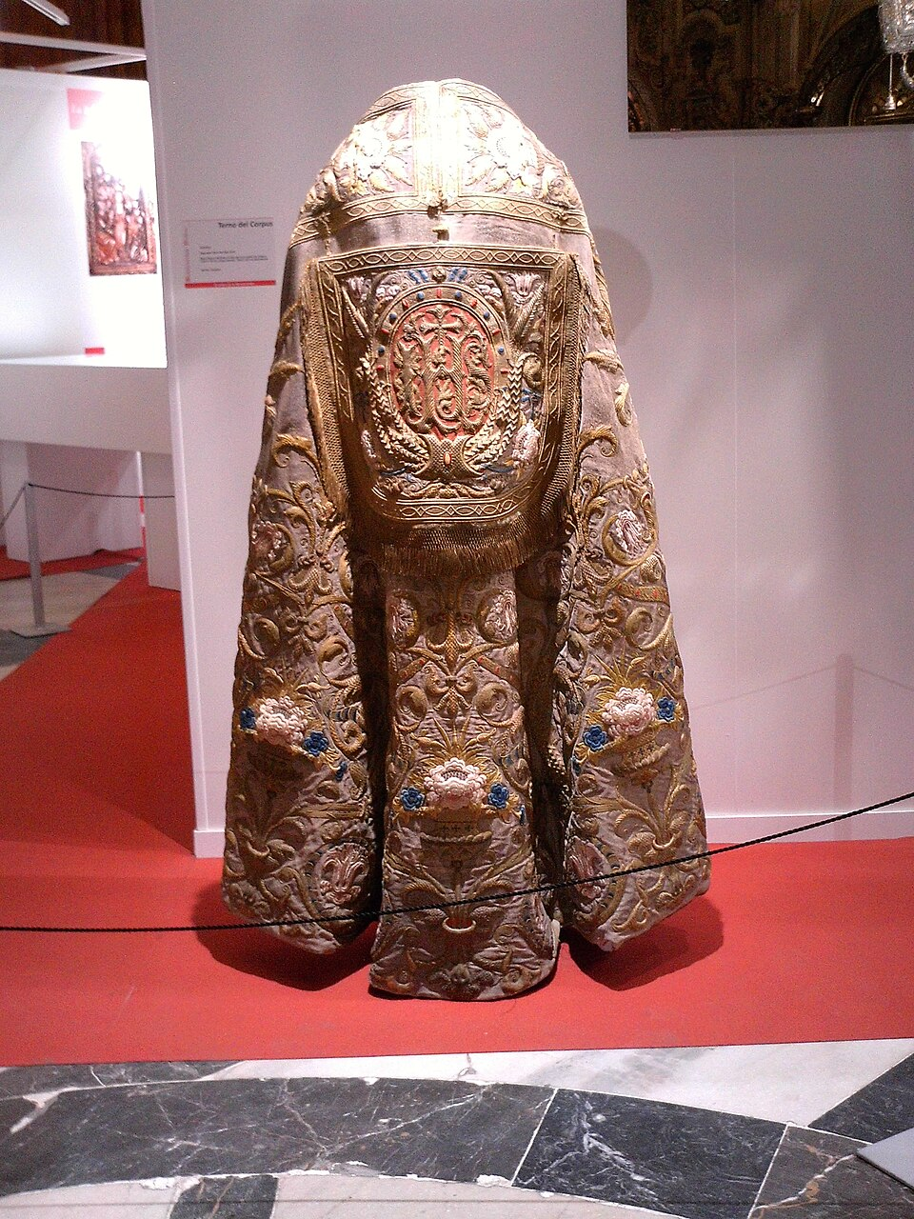

What is the appropriate place to see church artefacts?

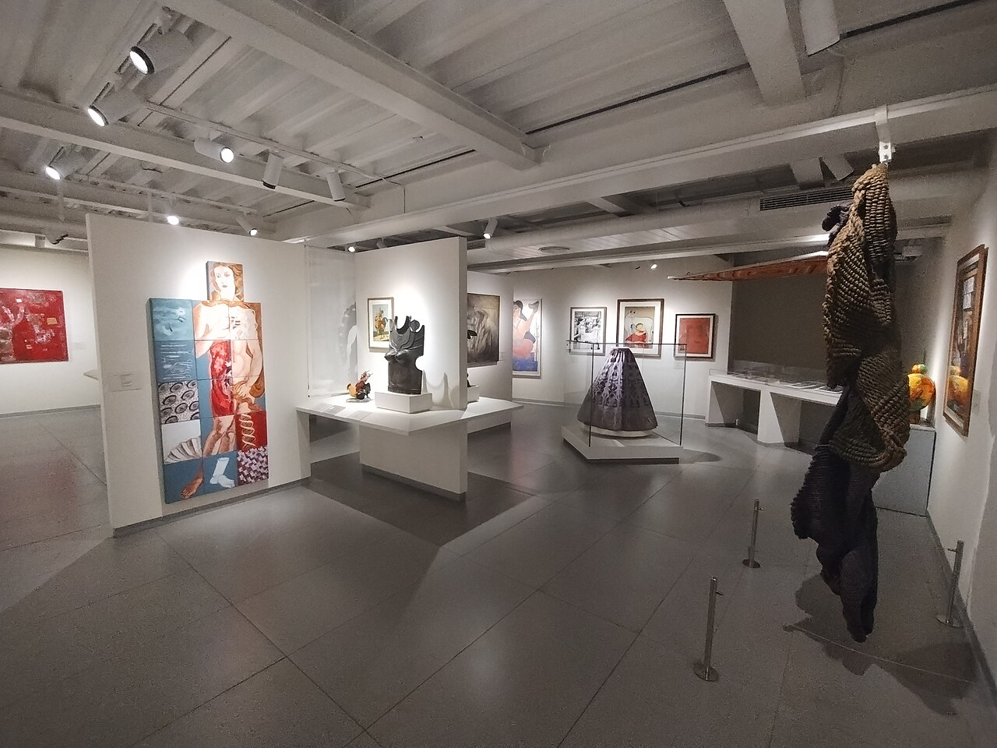

Is religious art, if it is accepted by curators, best surving God’s people in museums?, why or why not?

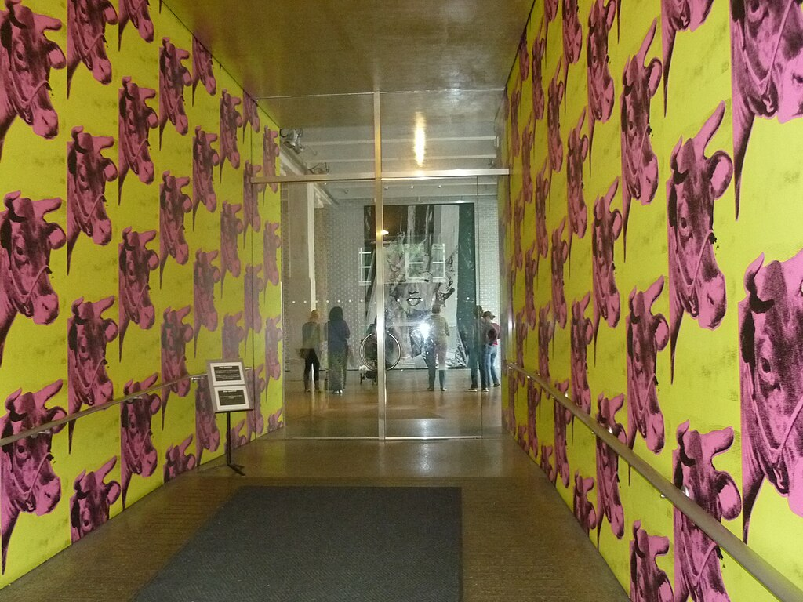Does reproduction (especially mass reproduction) change the nature of religious art? If you can replicate something widely, what does that say about the spiritual content? Does mass replication do anything helpful (like providing access?) or does it just imply profit to the mass producer?

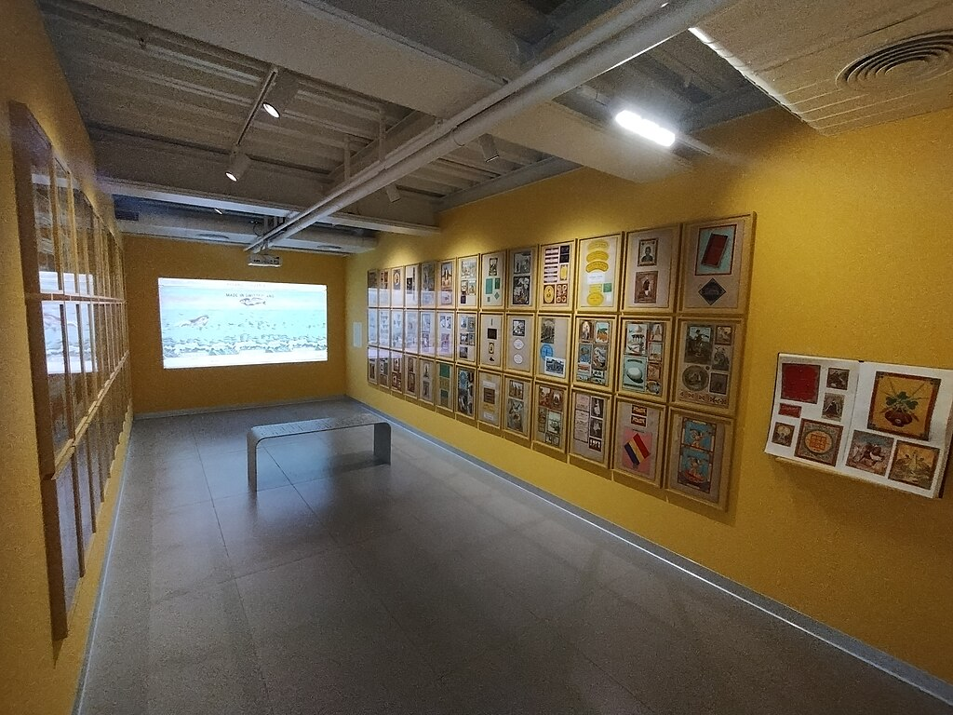

Art ‘came of age’ in a certain respect when it developed as its own institution outside of the church. Museums and galleries are now respected and funded right alongside schools, libraries, and other institutions as ‘spaces of learning’. Supposing we cannot completely say museums are ‘wholly good’ vs. ‘wholly bad’ for society, what can we argue they do to serve God’s kingdom already in their current form? How could they do more? What role do Christians have in these spaces, often ‘secular’ and funded by non-religious organizations or ‘secular’ governments?

### Activity: A History Lesson on Museums, Craftspeople, and Patrons

**<Begin learning-activity>**

**Estimated Time: 15 mins**

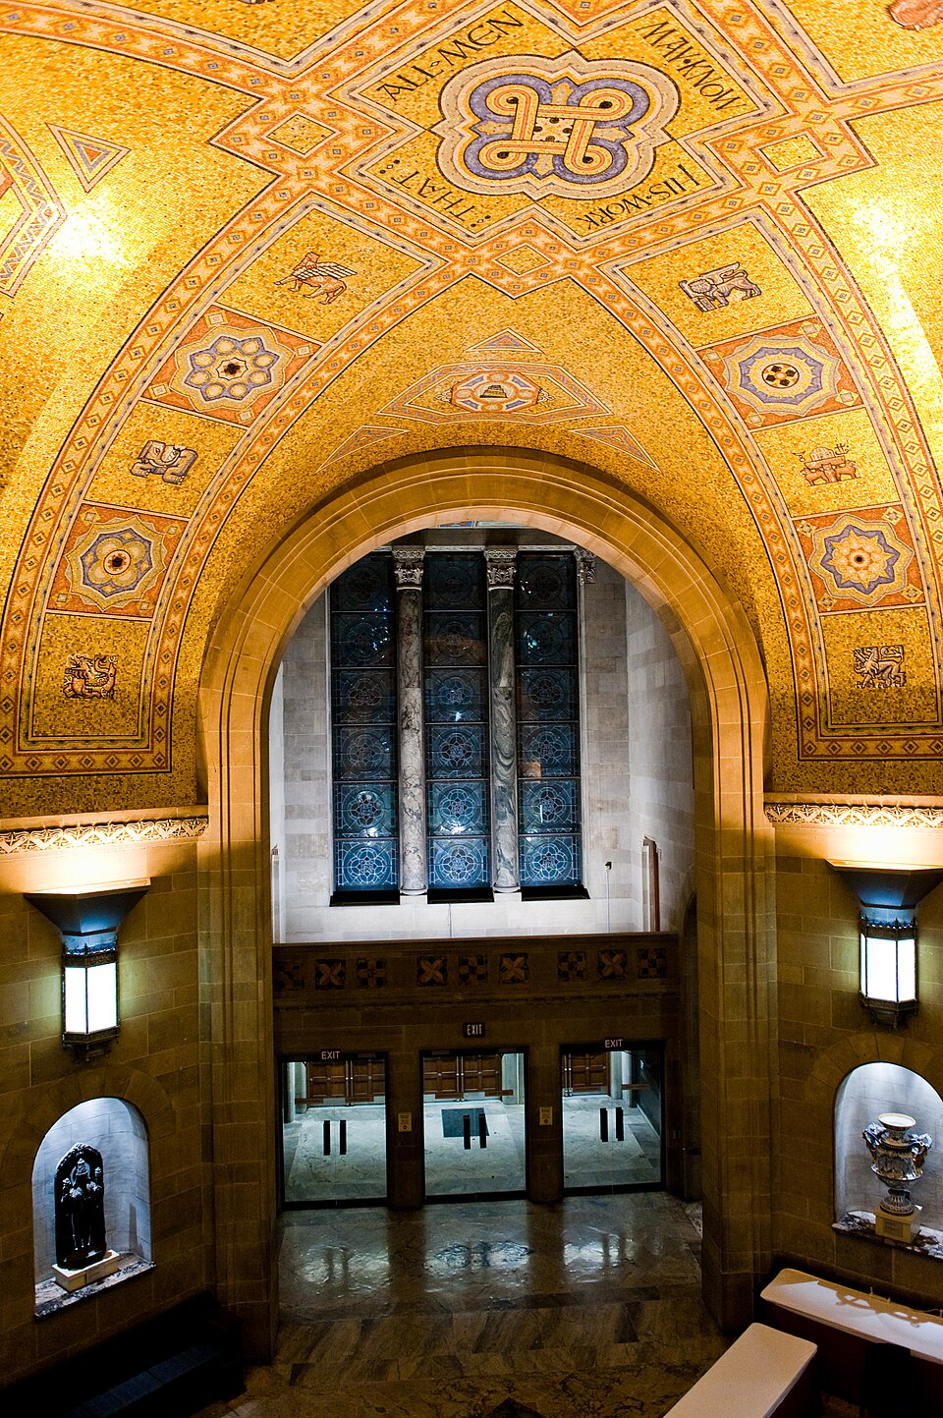

*A mosaic ceiling in the Royal Ontario Museum, Toronto, which reads ‘That all men may know His Work.’ The mosaic features “symbols of the civilizations of the world from the early ages of the Indigenous peoples of the Americas through to the European Middle Ages.”* [*This article from the Royal Ontario Museum*](https://www.rom.on.ca/media-centre/magazine/magnificent-rom-mosaic-ceiling)*, about trying to find the artisans and artist associated with the project, is interesting but the author goes absurd distances to avoid discussing the religious history associated with this ‘Byzantine style’, not mentioning the words at the centre or the fact that this kind of mosaic would be found in a church building. Rather, the author says the mosaic is said to express “unity in diversity.”*

From [*Wikimedia*](https://upload.wikimedia.org/wikipedia/commons/thumb/0/05/Mosaic_ceiling_at_the_ROM.jpg/960px-Mosaic_ceiling_at_the_ROM.jpg) (Unknown, 2009). Creative Commons.

In this short reading, Calvin Seerveld explains well the transition between artisans creating art for churches and the institutional museum model we have today: the good, the bad, and the ugly parts of this story.

* **Read:** Seerveld, “The Human Response,” in *Bearing Fresh Olive Leaves: Alternative Steps in Understanding Art* (2000), pp. 47–60.

**Question to Consider:**

* What surprised you the most about the changes to the patronage of the arts of over the last few centuries?
* What does Seerveld say are the benefits and drawbacks to the way this situation has changed?
* Can you think of any other benefits or limitations?

**<End learning-activity>**

### Activity: The Aesthetic Beyond the Museum

**<Begin learning-activity>**

**Estimated Time: 60 mins**

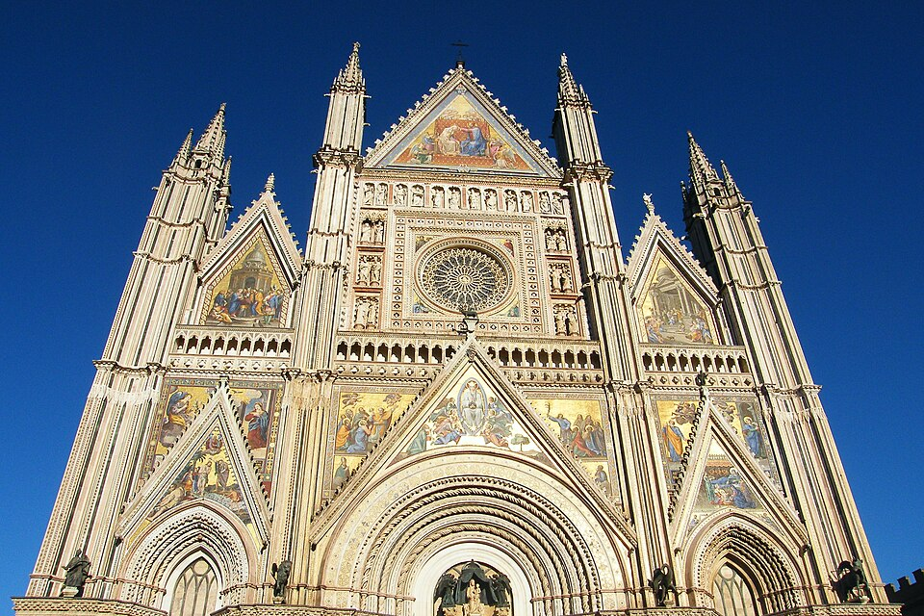

*The face of the Duomo in Orvieto, Italy.*

From [*Wikimedia*](https://upload.wikimedia.org/wikipedia/commons/thumb/9/98/Duomo-di-Orvieto.jpg/960px-Duomo-di-Orvieto.jpg) (Gerdy Ling, 2011). Creative Commons.

**Mandatory Reading:** Here are two short readings that focus on very distinct (but not contradictory) ways that Christians should imagine the integration of art beyond the museum. For John Skillen, the decontextualization of Christian art from places of worship has artificially adjusted our experience of it, and limits what it can mean for us as people of faith. Relatedly, Nicholas Wolterstorff discusses how the institutional model of ‘intellectual contemplation’ restricts us seeing all the other ways the aesthetic may be positively implicated in our lives, in the wider city, in our churches, homes and daily lives, etc. These readings will help you understand the role that museums may or may not play in supporting artists as Christians in and beyond our churches.

* **Read:** “[Introduction: The (Dis)Placement of Art](https://mytwu.sharepoint.com/sites/LearningDesign/Shared%20Documents/Forms/AllItems.aspx?id=%2Fsites%2FLearningDesign%2FShared%20Documents%2FSAMC%20Doc%2FSAMC%20I%20PHIL%20370%2F2%2E%20Units%2FReading%20Files%2F3%2E3%20Skillen%20Putting%20Art%20%28Back%29%20in%20its%20Place%2Epdf&viewid=40cf7fb5%2D2131%2D4adc%2Dbd1e%2D88296482bfbb&parent=%2Fsites%2FLearningDesign%2FShared%20Documents%2FSAMC%20Doc%2FSAMC%20I%20PHIL%20370%2F2%2E%20Units%2FReading%20Files)” (Skillen, 2016), pp. 1–21 (PDF).
* **Read:** Wolterstorff, “Liberation” and “Participation,” in *Art in Action: Toward a Christian Aesthetic* (1996), pp. 177–199.

**Questions to Consider:**

* How are Skillen and Wolterstorff’s concerns about the current context of art similar and different?
* Are there any works of art that you saw in a museum whose religious significance was downplayed? Any works of art you would like to see returned to a religious context?
* What are the benefits and drawbacks to putting art back in its place or origin? Note: this is a slightly different conversation than advocating for the return of stolen artwork such a through Colonial or Nazi pillaging (it was stolen, after all!, which is less the case with ‘decommissioned’ church art), but there is an overlapping concern about interpreting art somewhere besides its origin or intended context.
* Can you think of other places, in the same train of thought as Wolterstorff, where aesthetic attention has been lacking because of a hyper-fixation with museum art or art meant for ‘disinterested’ contemplation?

**<End learning-activity>**

## Summary

In this unit, you have had the opportunity to learn about art as a vocation that is appropriate for Christians and learned about the historical development of the museum that pulled a lot of art out of the church. You were invited to brainstorm how to support artists in your different community circles. You were also asked to reflect upon what liturgy and design contribute to the experience of worship, and to reconsider what museums, galleries, and concert halls offer Christian artists and believers at large. In the next unit, you will begin considering the aesthetic experience of not just liturgy, but all manner of activities in your week and your daily life.

## Checking Your Learning

**<Begin checking-your-learning>**

Before you move on to the next unit, you may want to check that you are able to:

* Describe the issues facing artists who want to make and sell work that deals explicitly with religious themes or is done from a Christian humanist perspective.
* Contrast differing perspectives about whether museums are good for society and Christian artists.
* Recognize different forms that artistic creativity can take in liturgy.
* Create new habits for supporting artists in your community.

**<End checking-your-learning>**

## References

* Anselm Society. (2019). John Skillen: Art and Christian Community – Anselm Society [Video]. Youtube. <https://www.youtube.com/watch?v=1UDWWUMEOBE>
* Michelle Panchuk’s essay, “Power and Protest: A Christian Liturgical Response to Religious Trauma”from Simmons, J. A., Benson, B. E., & DeRoo, N. (Eds.). (2023). *Philosophies of Liturgy: Explorations of Embodied Religious Practice*. Bloomsbury Publishing Plc, pg. 77-93. [PDF].
* Art and Theology. (2025). *Four site-specficic art installations in churches for Pentecost.* [*https://artandtheology.org/2025/05/30/art-installations-churches-pentecost/*](https://artandtheology.org/2025/05/30/art-installations-churches-pentecost/)
* Seerveld, C. (2000). *Bearing Fresh Olive Leaves: Alternative Steps in Understanding Art*. Toronto Tuppence Press.
* Simmons, J. A., Benson, B. E., & DeRoo, N. (Eds.). (2023). *Philosophies of Liturgy: Explorations of Embodied Religious Practice*. Bloomsbury Publishing Plc.
* Skillen, J. E. (2016). *Putting Art (Back) in Its Place*. Tyndale House Publishers.
* Smith, J. K. A. (2009). *Desiring the Kingdom (Cultural Liturgies): Worship, Worldview, and Cultural Formation*. Baker Academic.
* Wolterstorff, N. (1996). *Art in Action: Toward a Christian Aesthetic* (1st edition). Eerdmans.